Circular motion
Please remember to photocopy 4 pages onto one sheet by going A3→A4 and using back to back on the photocopier

This booklet contains every higher level (and most ordinary level) questions that have appeared on exam papers from 1971 – 2023
Note that this topic was usually Question 6 on the old syllabus (up to 2022)
Fully worked solutions from the legend that is Dominick Donnelly here appliedmathematics.ie/index.php/students/exam-solutions
Solutions to HL 2023 and Sample Paper (plus lots more) from Joe Kennedy here: https://www.jkmaths.net/exam-paper-solutions
Screencasts of worked solutions to HL 2023 and Sample Paper (plus lots more) from Shane Molloy here: https://www.molloymaths.com/applied-maths

Exam Papers (in pdf and Word format) plus Marking Schemes (and lots more) from: thephysicsteacher.ie/exammaterialappliedmaths.html
A good idea is to look at as many sources as you can for solutions as there is often more than one approach and some can be much easier to understand and/or remember than others.
Screencasts of worked solutions to various older past paper question plus comprehensive resources for all topics

Questions from 2023 and Sample Paper (Ordinary level and Higher level) are left until the very end – page 28

You can find this document plus all other Applied Maths booklets on the homepage of thephysicsteacher.ie

Last updated: 04/12/2023
Noel Cunningham

Contents
Introduction 3
Angular velocity 3
Radians 3
Revolutions 3
If an object is moving in a circle at constant speed, it is accelerating 3
Relationship between linear speed (v) and angular velocity (ω) 4
Centripetal force 5
Centripetal acceleration 5
Formulae for centripetal acceleration and centripetal force 5
Manipulation of equations 6
For you 8
Longer problems: Suggested approach in a nutshell 9
Your first step should be to draw two diagrams 10
A reminder of what your first page should look like 11
Particle on a string – horizontal motion: Ordinary Level 12
For You 14
Problems which involve a reaction force 15
Particle on a string – horizontal motion: Higher Level 17
Periodic time T 19
Cones and spheres questions without friction– Ordinary level 20
Cones and spheres questions without friction– Higher level 21
Cones and spheres questions with friction– introduction 22
Cones and spheres questions with friction– Ordinary level 23
Cones and spheres questions with friction– Higher level 23
Vertical motion 24
Particle on a string 24
Maximum and minimum tension in a string 26
Car doing a loop-the-loop 27
Calculate the least speed of projection needed to ensure that the particle reaches the top of the circle 28
Particle slides off the outside surface of a sphere 29
Bead on a hoop 30
Revision question: Sample Paper HL Question 6 31
Answers to ordinary level exam questions 32
Guide to answering higher level exam questions 35
A reminder of what your first page should look like 38

Introduction

Angular velocity

Angular velocity is the rate of change of angle with respect to time.
The symbol for angular velocity is ω (pronounced “omega”).
$$= \frac{}{t}$$

Mathematically ω = θ/t

Angular velocity is measured in radians per second (rad/s), so now we need to consider what a radian is.
where 2π radians corresponds to a full circle (360⁰).

Radians
An angle (in radians) is defined as the arc length divided by the radius
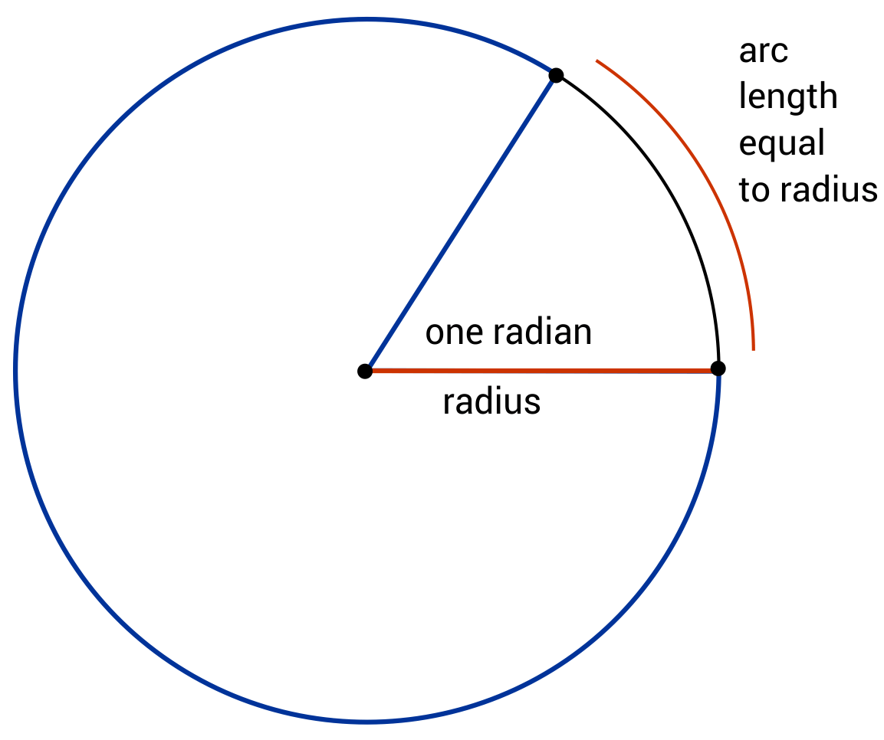
$$θ=\frac{arc length}{radius}$$

For a full circle the arc length is 2πr so using the equation above we get $θ=\frac{2πr}{r}$ = 2π radians.
Therefore the angle in a full circle is 2π radians (or 360⁰)

Revolutions
If the object is carrying out full revolutions, then the time corresponding to one full revolution is called the periodic time (symbol T).
Therefore in this case the expression $ω=\frac{θ}{t}$ becomes $ω=\frac{2π}{T}$
$$T= \frac{2π}{}$$

$$ω=\frac{2π}{T}$$
or

If an object is moving in a circle at constant speed, it is accelerating
This is because while its speed is not changing, its velocity is. Why? Because velocity is defined as speed in a given direction, so if direction is changing, even though speed is not, then the velocity is changing, therefore the object is accelerating.

Now for an object undergoing complete revolutions the frequency (f) of oscillation corresponds to the number of revolutions per second, where $f=\frac{1}{T}$
e.g. if the periodic time T = 0.2 seconds then the frequency f will be 5 (hertz).

Relationship between linear speed (v) and angular velocity (ω)
v = rω



You don’t need to know the derivation below (although you do for your Physics course)

$$Angle (in radians)=\frac{arc length}{radius}$$
In symbols: $θ=\frac{s}{r}$
Now divide both sides by t | $$\frac{θ}{t}=\frac{s}{r}×\frac{1}{t}$$
Rearrange the right hand side | $$\frac{θ}{t}=\frac{s}{t}×\frac{1}{r}$$
But $\frac{θ}{t}$= ω and $\frac{s}{t}$ = v | ω = $v×\frac{1}{r}$
Multiply both sides by r to get v on its own | ⇒ rω = v

v = rω

Centripetal force
A force - acting in towards the centre - required to keep an object moving in a circle is called a centripetal force.
Examples of centripetal forces are gravity (for satellites), friction (for a car going around a bend and tension in a string (if tied to a weight moving in a circular fashion).
So the term centripetal force is an umbrella term that covers all forces that result in circular motion – it is not itself a force.

Centripetal acceleration
If a body is moving in a circle then its acceleration towards the centre is called centripetal acceleration.

Formulae for centripetal acceleration and centripetal force

The first derivation here requires quite a long derivation so we’re just going to present it as is. All the others
however follow directly.
$a= \frac{v^{2}}{r}$
a = rω²
but because v = rω we also have

F = mrω²
And because F = ma we get and also

Manipulation of equations
The worked solutions here should follow the same approach as for the vuast equations with linear acceleration; write down everything you know on the left hand side and then pick the relevant equation before then subbing in the variables.

2009 (a) OL  A particle describes a horizontal circle of radius 0.5 m with uniform angular velocity ω radians per second.  Its acceleration is 8 m/s².  - Find the value of ω | Solution  r = 0.5 m  a = 8 m/s²  ω = ?  a =rω² 0.5ω² = 8 ⇒ ω = 4 rad/s
- Find the time taken to complete one revolution. | Solution  Periodic time = T = 2π/ω  The time taken to complete one revolution = T  ω = 4 rad/s $T= \frac{2π}{}$ $T= \frac{2π}{4}$  $T= \frac{π}{2}$ s

2008 (a) OL  A particle describes a horizontal circle of radius 2 metres with constant angular velocity ω radians per second.  Its speed is 5 m/s and its mass is 3 kg.  - Find the value of ω | Solution  r = 2 m  v = 5 m/s  m = 3 kg  ω = ?  v = rω 5 = 2ω ω = 2.5 rad/s
- Find the centripetal force on the particle. | Solution  r = 2 m  m = 3 kg  ω = 2.5 rad/s  F =?  Force = mrω² = (3)(2)(2.5²) = 37.5 N

2007(a) OL  A particle describes a horizontal circle of radius r m with uniform angular velocity ω radians per second.  Its speed and acceleration are 2 m/s and 4 m/s² respectively.  - Find the value of r | Solution  v = 2 m/s  a = 4 m/s²  r = ?  $a= \frac{v^{2}}{r}$ ⇒ $4= \frac{2^{2}}{r}$ ⇒ r = 1 m
- Find the value of ω. | Solution  v = 2 m/s  r = 1 m  ω = ?  v = rω ⇒ $ω=\frac{v}{r}$ ⇒ $ω=\frac{2}{1}$  ω = 2 rad/s

For you
2015 (a) OL
A particle describes a horizontal circle of radius 2 m with uniform angular velocity ω radians per second.
The particle completes 10 revolutions every minute.
Find
- the value of ω
- the speed and acceleration of the particle

2010 (a) OL
A particle describes a horizontal circle of radius r metres with uniform angular velocity ω radians per second.
Its speed and acceleration are 6 m s⁻¹ and 12 m s⁻² respectively.
Find
- the value of r
- the value of ω .

2006 (a) OL
A particle describes a horizontal circle of radius 2 metres with constant angular velocity ω radians per second.
The particle completes one revolution every 5 seconds.
- Show that ω is equal to 2π/5.
- Find the speed and acceleration of the particle.
Give your answers correct to one place of decimals.

2014 (a) OL
A particle describes a horizontal circle of radius 2 metres with uniform angular velocity ω radians per second.
The period T (the time to travel one complete circle) is 0.4 $π$ seconds.
Find
- the value of ω
- the speed of the particle
- the acceleration of the particle.

2016 (a) OL
A particle describes a horizontal circle of radius 1·5 metres with uniform angular velocity ω radians per second. Its speed is 3 m s⁻¹ and its mass is 2 kg.
- Find the value of ω
- Find the time to complete one revolution
- Find the centripetal force on the particle.

2017 (a) OL
A particle describes a horizontal circle of radius 0·5 metres with uniform angular velocity 3 radians per second. The mass of the particle is 2 kg.
Find
- the speed of the particle
- the acceleration of the particle
- the horizontal force on the particle
- the time taken by the particle to complete nine revolutions.

Longer problems: Suggested approach in a nutshell

Pick one equation from the left and one equation from the right and solve!
It’s a good idea to divide your page in two (vertically) to remind yourself of what you’re doing

Equation 1 | Equation 2
Forces up = Forces down  (if the object is moving in a horizontal plane)  OR  Conservation of energy  {P.E. + K.E. is constant}  (if the object is moving in a vertical plane) | $F_{net (towards the centre)}= \frac{{mv}^{2}}{r}$  (if the question involves linear velocity v)  OR  $$F_{net(towards the centre)}= {mr}^{2}$$  (if the question involves angular velocity ω)

One of the trickier aspects to these questions is determining which forces to include for each equation.
The acceleration of the object is towards the centre, so we can only consider forces (or their components) which are acting along this line – either acting directly towards or directly away from the centre.

Your first step should be to draw two diagrams

A helpful approach is to draw two diagrams along the top of your first page

It is also a good idea (code for Just Feckin’ Do It!) to draw two diagrams; one representing the geometry of the setup and the other showing all the forces. A rookie error is to try and put all the information on one diagram. This invariably results in the student mixing up forces and lengths in subsequent calculations (particularly when calculating the sine or cosine of an angle).

Note that the angles will be the same for both diagrams.

Diagram 1: Geometry diagram | Diagram 2: Forces diagram
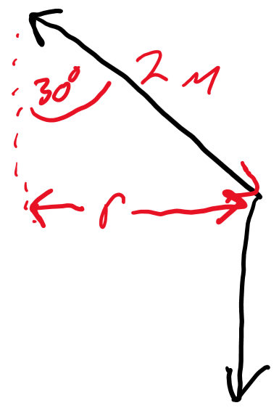 | 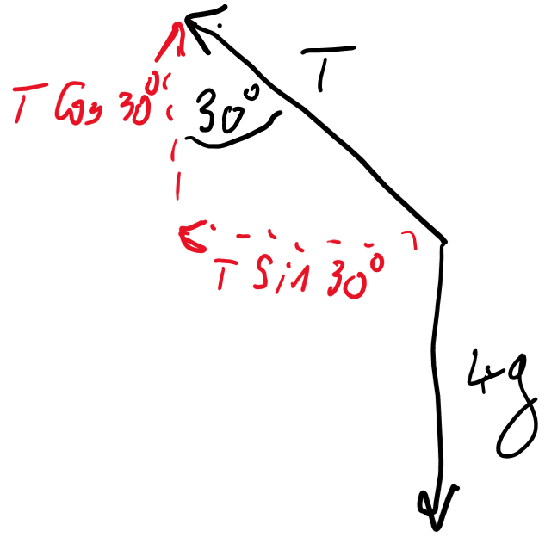

A reminder of what your first page should look like

Diagram 1: Geometry diagram | Diagram 2: Forces diagram

Now for our two equations

Force up = Force down | Net force inwards = $\frac{mv^{2}}{r}$  OR  Net force inwards = mrω²

Particle on a string – horizontal motion: Ordinary Level
- Forces up = Forces down equation 1

- $Net Force Inwards= \frac{{mv}^{2}}{r}$ equation 2

- Solve both equations

Consider a particle attached by a light inelastic string to a fixed point P.
The particle describes a horizontal circle on the surface of a horizontal table.

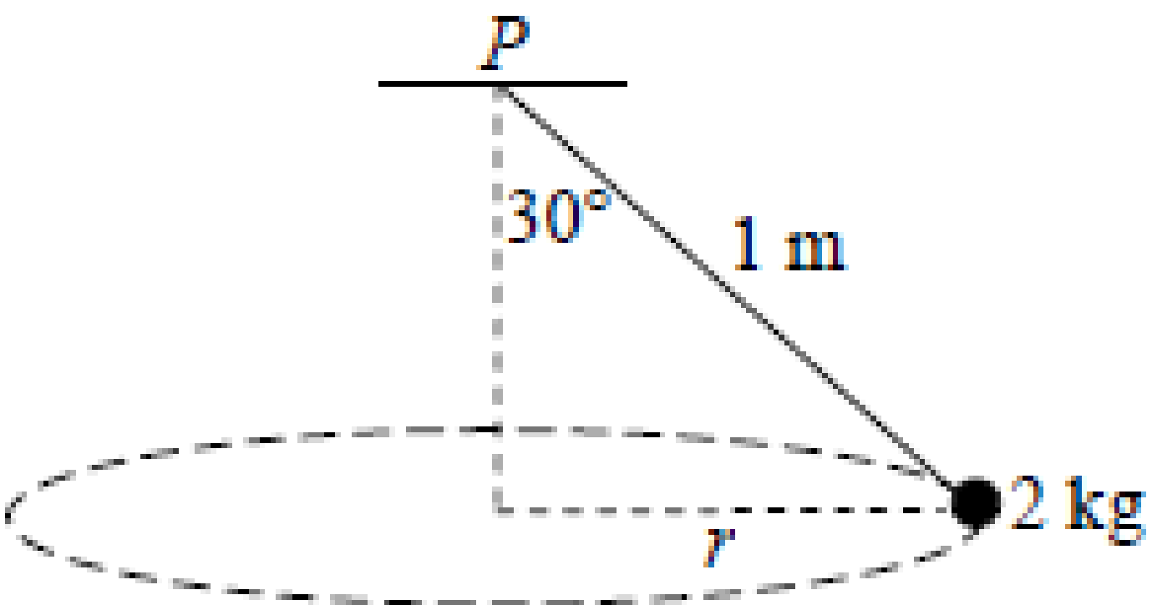

The centre of the circle is vertically below P. By definition, any particle moving in a circular path is accelerating towards the centre therefore we are only interested in the forces (or components of forces) acting either towards the centre or directly away from it.

The single greatest issue that students (or any of us for that matter) have with circular motion questions is trying to get our heads around the fact that the direction of the object’s acceleration is towards the centre. How can this be – the object is clearly not travelling into the centre.
The difficulty arises from the fact that we associate the direction of an object’s acceleration to the be the same as the direction in which the object is moving but one does not follow from the other. They both may be in the same direction – and many of the examples we use in linear acceleration chapter do indeed have this relationship – but they don’t have to be.

The direction in which an object is accelerating is determined by the direction of the force which is causing that acceleration – it’s as simple (and headwrecking) as that.

By the way, we have come across a variation of this before but just never really thought about it too much; if we throw a stone up it its acceleration is downward, both while the stone is moving up and when it’s moving back down.

Worked example
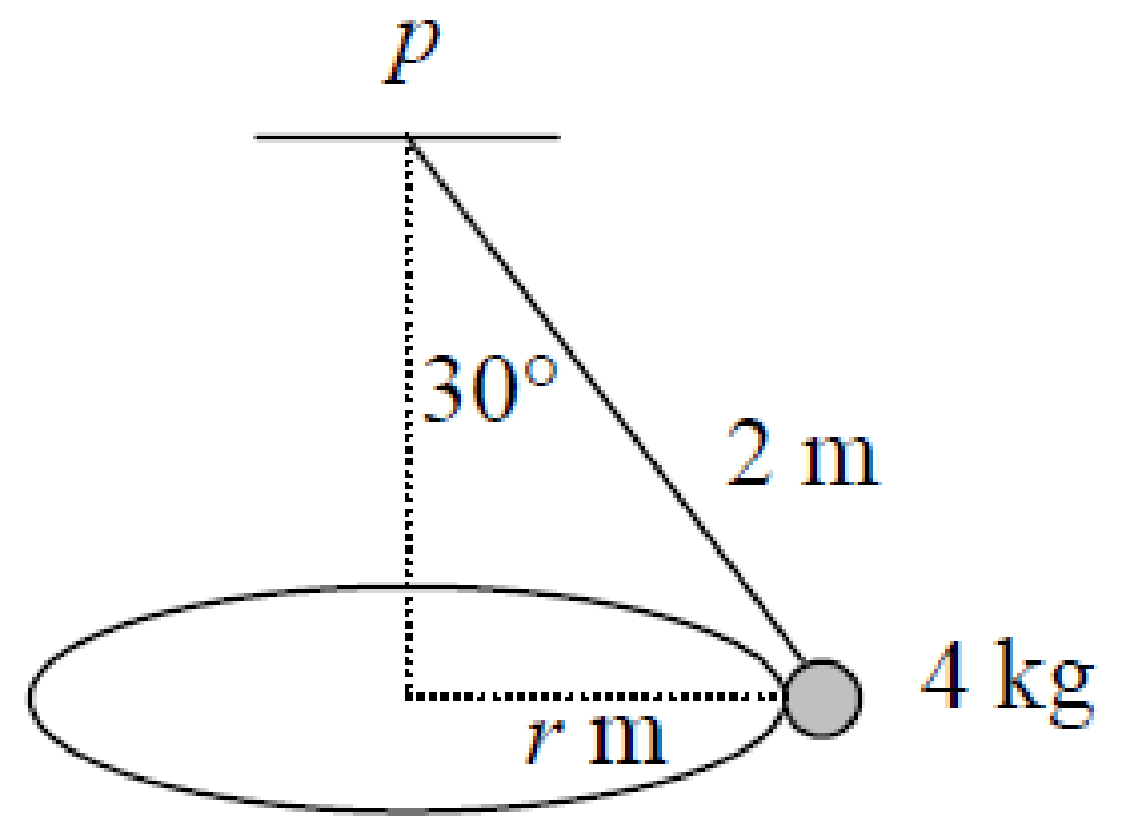
2006 (b) OL
A conical pendulum consists of a particle of mass 4 kg attached by a light inelastic string of length 2 metres to a fixed point p.
The particle describes a horizontal circle of radius r.
The centre of the circle is vertically below p.
The string makes an angle of 30⁰ with the vertical.
Find
- the value of r
- the speed of the particle.
- the tension in the string

Solution

Diagram 1: Geometry diagram | Diagram 2: Forces diagram
sin 30 = r/2
Therefore r = 2 sin 30 = 1 m

Now for our two equations

Force up = Force down | Net force inwards = $\frac{mv^{2}}{r}$
T cos 30 = 4g  ⇒ $T= \frac{80}{\sqrt{3}}$ N | The only force that’s acting in towards the centre is the horizontal component of the tension: T sin 30  T sin 30 = $\frac{mv^{2}}{r}$  $\frac{80}{\sqrt{3}}$(0.5) = $\frac{4v^{2}}{1}$  ⇒ v = 2.4 m s⁻¹

For You
2014 (b) OL
A conical pendulum consists of a particle of mass 2 kg attached by a light inelastic string of length 1 metre to a fixed point P.
The string makes an angle of 30° with the vertical.
The particle describes a horizontal circle of radius r and the centre of the circle is vertically below P.
Find
- the value of r
- the tension in the string
- the angular velocity of the particle.

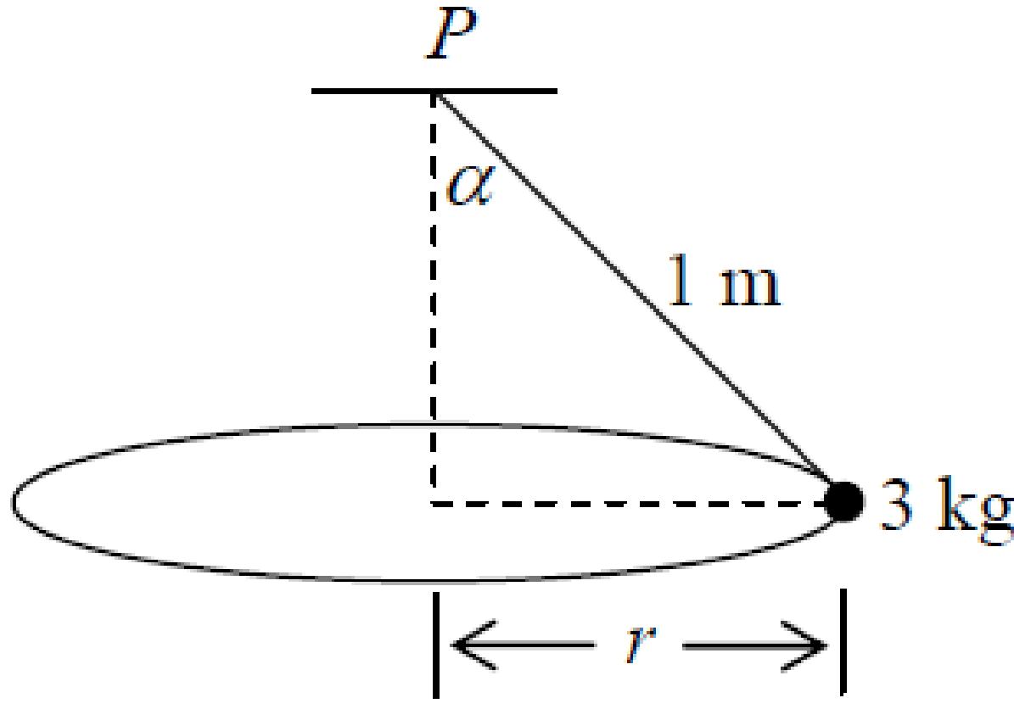
2010 (b) OL
A conical pendulum consists of a particle of mass 3 kg attached by a light inelastic string of length 1 metre to a fixed point P.
The particle describes a horizontal circle of radius r.
The centre of the circle is vertically below P.
The string makes an angle of ⟨ with the vertical where tan ⟨ = 4/3.
Find
- the value of r
- the tension in the string
- the angular velocity of the particle.

2023 OL Question 2 (b)
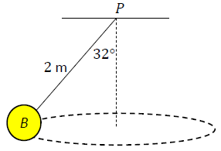
Ball 𝐵, of mass 5.5 kg, is connected to a fixed point 𝑃 by a light inextensible string of length 2 m.
The ball moves in a horizontal circle, where the centre of the circle is vertically below 𝑃.
The string makes an angle of 32° with the vertical, as shown in the diagram.
- Draw a labelled diagram to show the forces acting on 𝐵.
- Calculate the tension in the string.
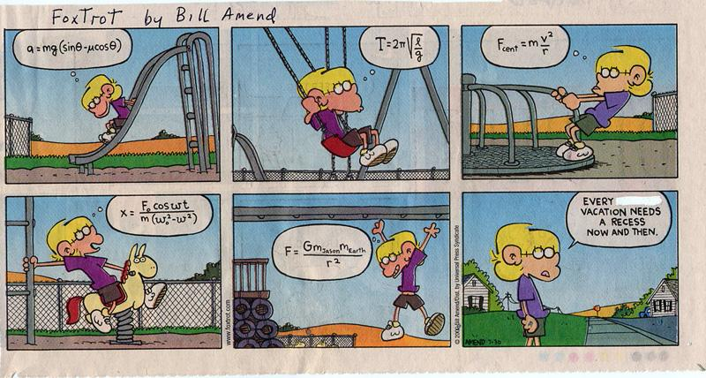
- Calculate 𝜔, the angular velocity of the ball.

Problems which involve a reaction force

If the object undergoing circular motion happens to be on a surface such as a table then we will also have a normal reaction force to consider. The convention used to be to label this force as ‘R’ but the convention is slowly changing and we now prefer to use the term ‘N’ for ‘normal’ reaction force (the word ‘normal’ emphasises that this force is always perpendicular to the surface at the point of contact, something which may seem obvious if the surface is horizontal, but also applies when the surface is a slope.

Worked example 2005 (a) OL
A smooth particle of mass 4 kg is attached to the end of a light inextensible string 50 cm in length.
The mass describes a horizontal circle with constant speed 3 m/s on a smooth horizontal table.
The centre of the circle is also on the table.
- Show on a diagram all the forces acting on the particle.
- Find the tension in the string.
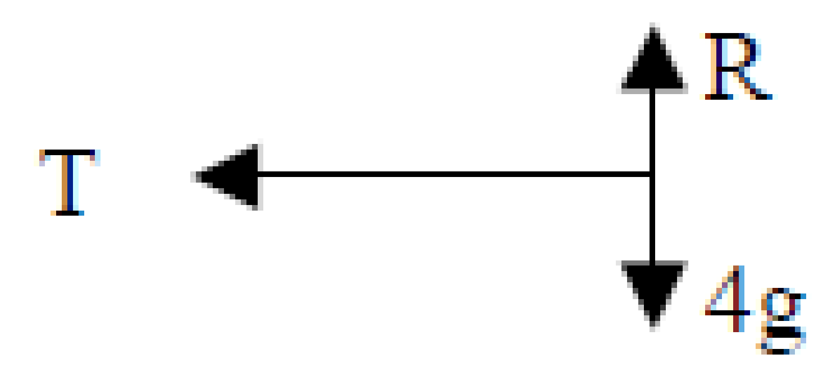
Solution
- See diagram

- T = mv²/r T = 4(3)²/0.5 ⇒ T = 72 N

For you

2007 (b) OL
A smooth particle of mass 2 kg is attached by a light inelastic string to a fixed point p.
The particle describes a horizontal circle of radius 0.5 m on the smooth surface of a horizontal table.
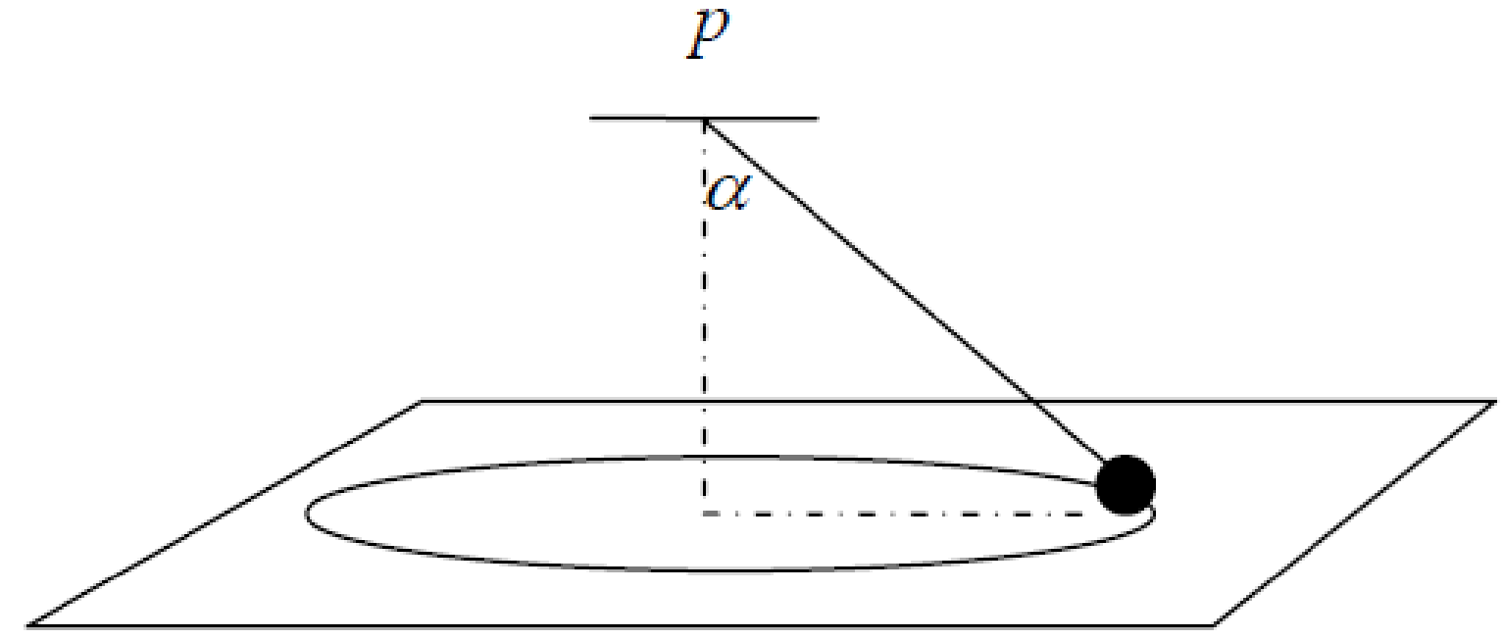
The centre of the circle is vertically below the point p.
The string makes an angle α with the vertical, where tan α = ¾.
The tension in the string is 15 newtons.
Find
- the reaction force between the particle and the table
- the angular speed of the particle.

2004 (a) OL
A boy ties a 1 kg mass to the end of a piece of string 50 cm in length.
He then rotates the mass on a smooth horizontal table, so that it describes a horizontal circle whose centre is also on the table.
If the string breaks when the tension in the string exceeds 8 newtons, what is the greatest speed with which the boy can rotate the mass?

2005 (b) OL
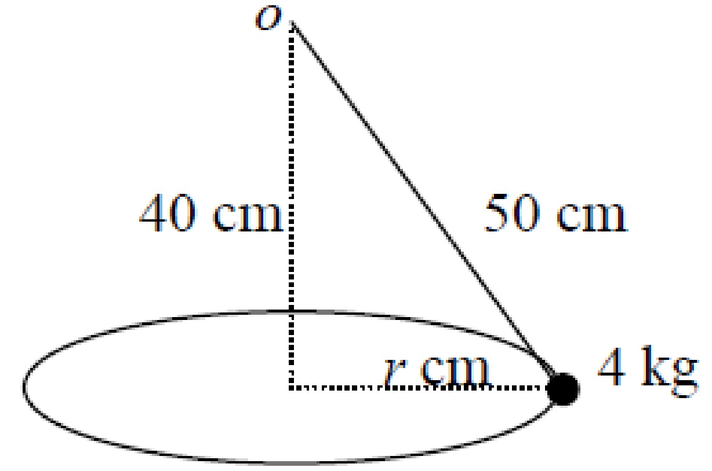
A smooth particle, of mass 4 kg, describes a horizontal circle of radius r cm on a smooth horizontal table with constant speed 1.2 m/s.
The particle is connected by means of a light inelastic string to a fixed point o which is 40 cm vertically above the centre of the circle.
The length of the string is 50 cm.
- Find the value of r.
- Find the tension in the string.
- Find the normal reaction between the particle and the table.

2015 (b) OL
A smooth particle of mass 2 kg is attached by a light inelastic string to a fixed point P.
The particle describes a horizontal circle of radius 0.25 m on the smooth surface of a horizontal table.
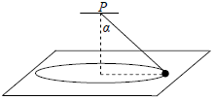
The centre of the circle is vertically below P.
The string makes an angle α with the vertical, where tan α =$\frac{4}{3}$.
The speed of the particle is 1.2 m s^{‒1}.
Find
- the tension in the string
the reaction force between the particle and the table.

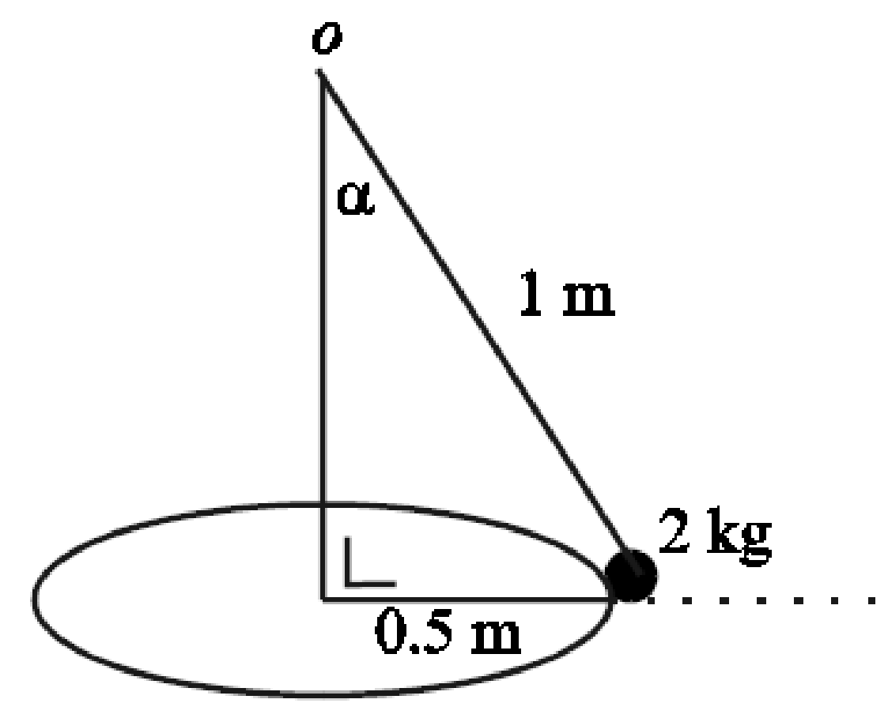
2003 (b) OL
A smooth particle, of mass 2 kg, describes a horizontal circle of radius 0.5 metres on a smooth horizontal table with constant angular velocity 3 radians per second.
The particle is connected by means of a light inelastic string to a fixed point o which is vertically above the centre of the circle.
The length of the string is 1 metre.
The inclination of the string to the vertical is α.
- Find α.
- Find the tension in the string.
- Show that the normal reaction between the particle and the table is 20 − 9√3 N.

2002 OL
A particle of mass 5 kg describes a horizontal circle of radius 0.7 metres with constant angular velocity ω radians per second on a smooth horizontal table.
The particle is connected by means of a light inextensible string to a fixed point o which is vertically above the centre of the circle.
The inclination of the string to the vertical is α, where tan α = ½.
The tension in the string is T newtons, the normal reaction between the particle and the table is R newtons and R = T√5.
- Write down the value of sin α and the value of cos α.
- Show on a diagram all the forces acting on the particle.
- Find the value of T and the value of R.
- Find the value of ω.

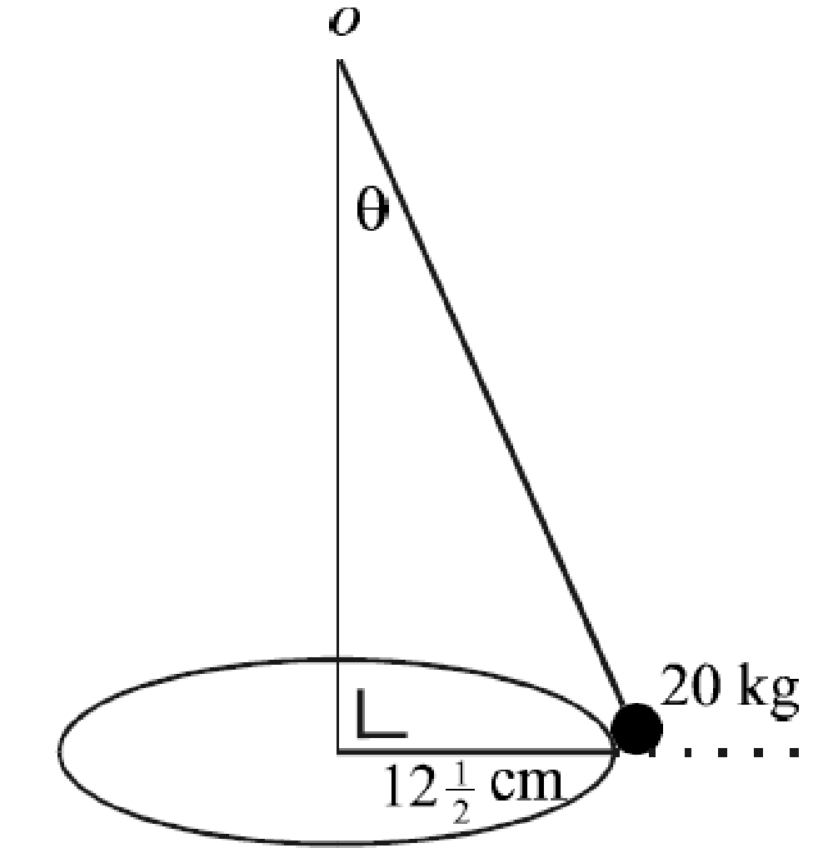
2000 OL
A particle of mass 20 kg describes a horizontal circle of radius length 12 ½ cm with constant angular velocity of 4 rad/s on a smooth horizontal table.
The particle is connected by means of a light inextensible string to a fixed point o which is vertically above the centre of the circle.
The inclination of the string to the vertical is θ, where $\tan{θ=\frac{5}{12}}$.
- Show on a diagram all the forces acting on the particle.
- Show that the value of the normal reaction between the particle and the table is equal to the value of the tension in the string.

Particle on a string – horizontal motion: Higher Level

1981 (b)
A heavy particle is describing a circle on a smooth horizontal table with uniform angular velocity ω.
It is partially supported by a light inextensible string attached to a fixed point 0.1 metres above the table. Calculate the value of ω if the normal reaction of the table on the particle is half the weight of the particle.

2008 (b)
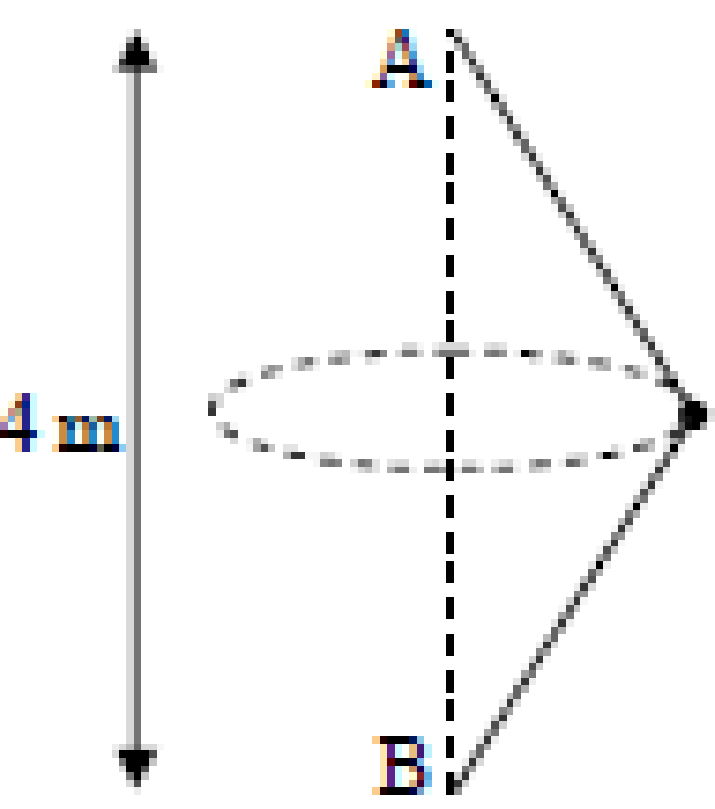
A and B are two fixed pegs, A is 4 m vertically above B.
A mass m kg, connected to A and B by two light inextensible strings of equal length, is describing a horizontal circle with uniform angular velocity ω.
For what value of ω will the tension in the upper string be double the tension in the lower string?

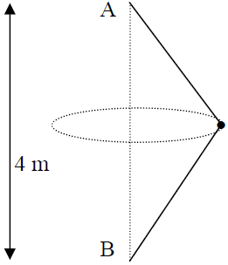
2011 (b)
A and B are two fixed pegs.
A is 4 m vertically above B.
A mass m kg, connected to A and B by two light inextensible strings of equal length, l, is describing a horizontal circle with uniform angular velocity ω.
Find the value of ω if the ratio of the tensions in the two strings is 11: 9.

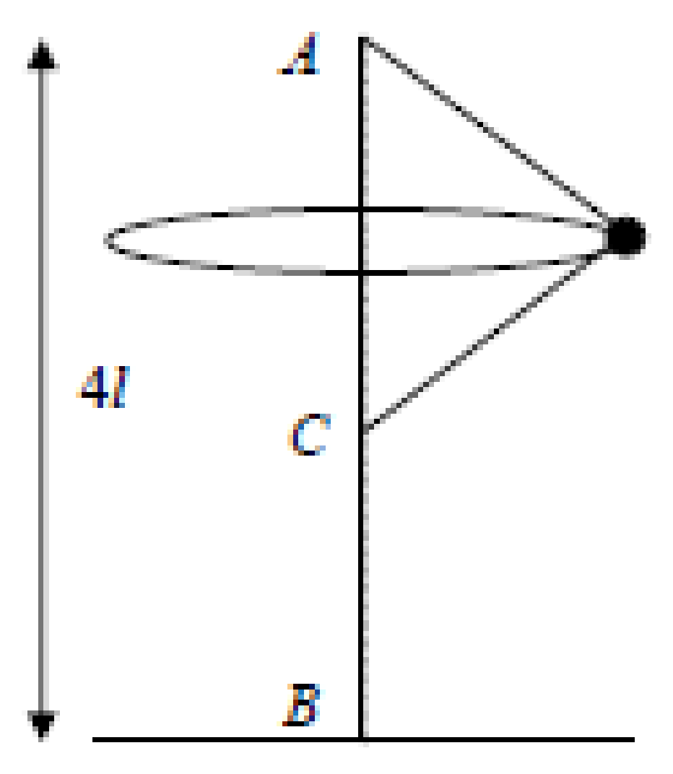

2013 (b)
A vertical rod BA, of length 4l, has one end B fixed to a horizontal surface with the other end A vertically above B.
The ends of a light inextensible string, of length 4l, are fixed to A and to a point C, a distance 2l below A on the rod.
A small mass m kg is tied to the mid-point of the string. It rotates, with both parts of the string taut, in a horizontal circle with uniform angular velocity ω.
- Find the tension in each part of the string in terms of m, l and ω.
- At a given instant both parts of the string are cut. Find the time (in terms of l) which elapses before the mass strikes the horizontal surface.

2019 (a)
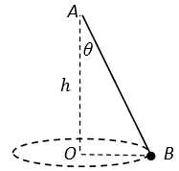
One end A of a light elastic string is attached to a fixed point.
The other end, B, of the string is attached to a particle of mass m.
The particle moves on a smooth horizontal table in a circle with centre O, where O is vertically below A and |AO|=ℎ.
The string makes an angle 𝜃 with the downward vertical and B moves with constant angular speed 𝜔 about OA.
- Show that 𝜔² ≤ $\frac{g}{h}$.
- The elastic string has natural length ℎ and elastic constant $\frac{2mg}{h}$.
Given that 𝜔² = $\frac{2g}{5h}$ , find the value of 𝜃.

1988
A particle of mass 8 kg is describing a circle, with constant speed v, on a smooth horizontal table.
It is connected by a light inextensible string of length 3 m to a point which is 1 m vertically above the centre of the circle.
- Calculate the tension in the string.
- Show that the particle will remain in contact with the table if $v<\sqrt{8g}$.
- If the speed of the particle is increased to$\sqrt{9.1g}$, calculate the height at which the particle rotates above the table.

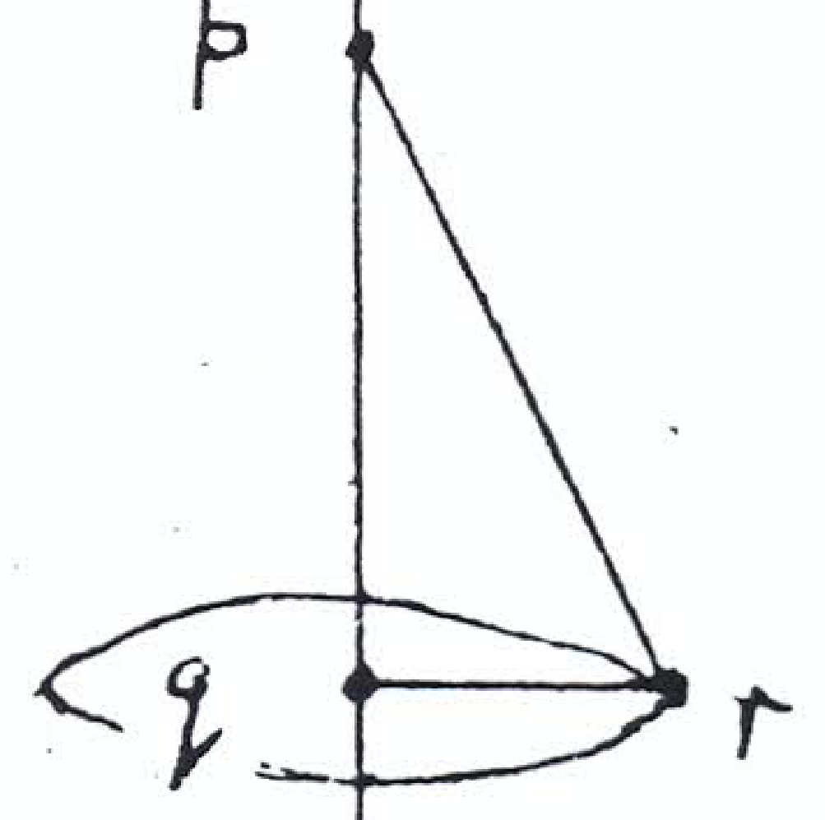
1982 (a)
The diagram shows a string prq which is fixed at p and where q is vertically below p. r is a smooth ring threaded on the string which is made to rotate at an angular velocity ω rad/s in a horizontal circle centre q, the string being taut.
If |pq| = 0.12 m, |pr| + |rq| = 0.18 m, show that ω = $\sqrt{294}$ rad/s.

1984 (b)
Two particles of equal mass attached by a taut inextensible string of length 2y rests on a horizontal circular table.
The particles are respectively y and 3y from the centre of the table so that centre and particles are collinear. The table rotates about its centre with angular velocity ω and the coefficient of friction is ^{y}/₂.
If both particles are on the point of slipping,
- show on a diagram, all the forces of the string/particle system
- calculate ω.

2023 HL Question 3
The photograph on the right is of a chain swing ride in an amusement park.
The disk at the top of the ride is rotating in a horizontal plane.
People sit in seats which are attached freely by inextensible chains of length 4.3 m to fixed points on the disk.
The chain attaching seat 𝐴 hangs from point 𝑋 on the ride and makes an angle 𝛼 with the vertical. 𝑋 is 3.5 m from the axis of rotation, which is the vertical line 𝑃𝑄, as shown in the diagram below.
The chain is free to swing in or out relative to 𝑃𝑄.
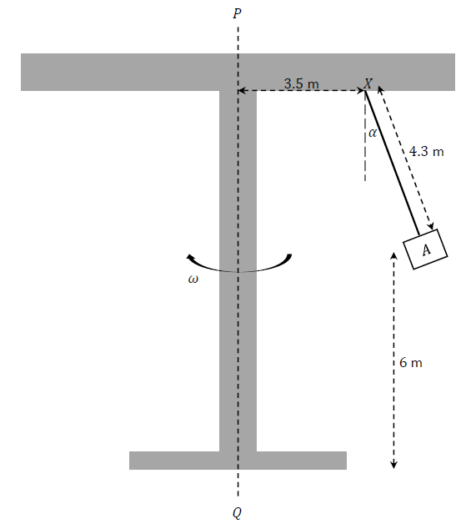
The ride rotates about 𝑃𝑄 with constant angular velocity 𝜔. Seat 𝐴 moves in a horizontal circular path which is 6 m above the ground.

- Draw a diagram to show the external forces acting on seat 𝐴.
- Show that $ω=\sqrt{\frac{g \tan{α}}{3.5+4.3 \sin{α}}}$
- It is found by measurement that 𝛼 = 25°.
Calculate how many complete revolutions the ride makes in one minute.
- The person sitting in seat 𝐴 throws a small orange into the air.
The person imparts an upward vertical velocity component of 4 m s^{–1} to the orange.
Calculate the time from when the orange is thrown until it hits the ground.

Periodic time T

Here we need to remember the relationship $T= \frac{2π}{ω}$
2005 (a)
A conical pendulum consists of a light inelastic string [pq], fixed at the end p, with a particle attached to the other end q
The particle moves uniformly in a horizontal circle whose centre o is vertically below p
If $\left\lceil PO\right\rceil$ = h, find the period of the motion in terms of h.

1995 (a)
A light string [op], of length l, is fixed at end o, and is attached at the other end p to a particle which is moving in a horizontal circle whose centre is vertically below and distant h from o.
Prove that the period of the motion is $2π\sqrt{\frac{h}{g}}$.

Cones and spheres questions without friction– Ordinary level

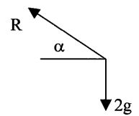
We mentioned previously that when a particle is on a surface we have to include a normal reaction force and that the word ‘normal’ is there to remind us that the force is perpendicular to the surface at that point. So for the question below the forces acting on the particle are as shown on the right.
However the procedure for solving the rest of the problem is the very same as if the particle was moving in circular fashion at the end of a string, it’s just that the tension force in a string ‘T’ is now replaced by the normal reaction force which we label ‘R’ or ‘N’.

2001 OL
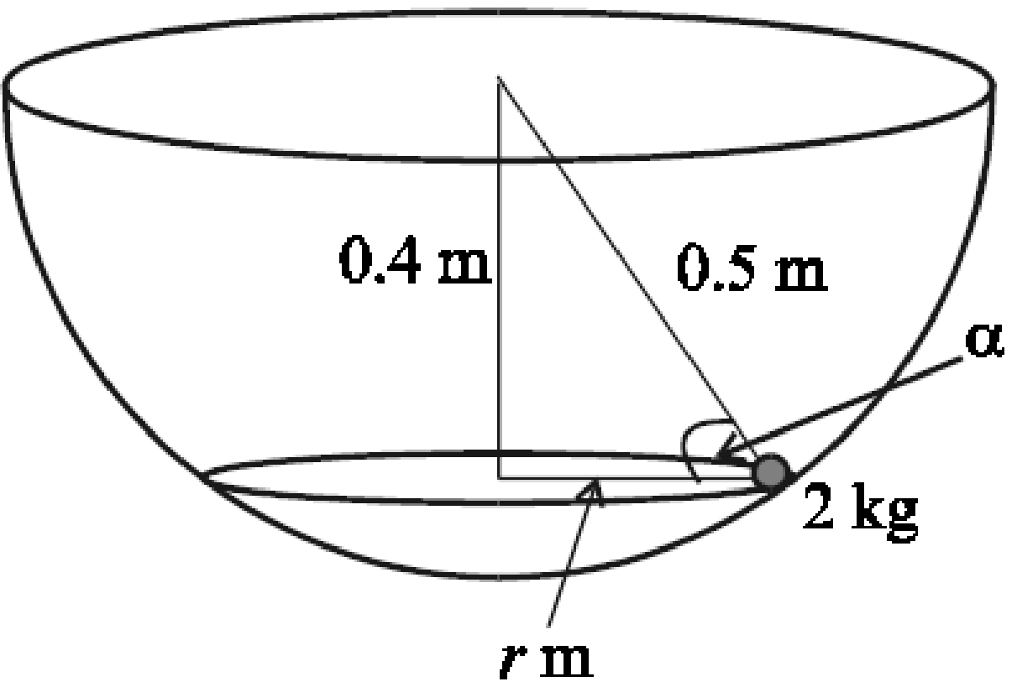
A smooth particle of mass 2 kg describes a horizontal circle of radius r metres with constant angular velocity ω radians per second on the smooth inside surface of a hemispherical bowl of radius 0.5 metres.
The centre of the horizontal circle is
0.4 metres vertically below the centre of the circle formed by the rim of the bowl.
The normal reaction between the particle and the bowl makes an angle α with the horizontal.
- Find the value of r.
- Write down the value of cos α and of sin α.
- Show on a diagram all the forces acting on the particle.
- Find the normal reaction between the particle and the bowl.
- Find the value of ω.

2017 (b) OL
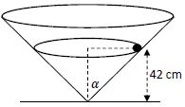
A right circular hollow cone is fixed to a horizontal surface.
Its semi-vertical angle is α° where $tan α =\frac{20}{21}$.
A smooth particle of mass 2 kg describes a horizontal circle of radius r cm on the smooth inside surface of the cone.
The plane of the circular motion is 42 cm above the horizontal surface.
- Find the value of r.
- Show on a diagram all the forces acting on the particle.
- Find the reaction force between the particle and the surface of the cone.
- Calculate the speed of the particle.

2008 (b) OL
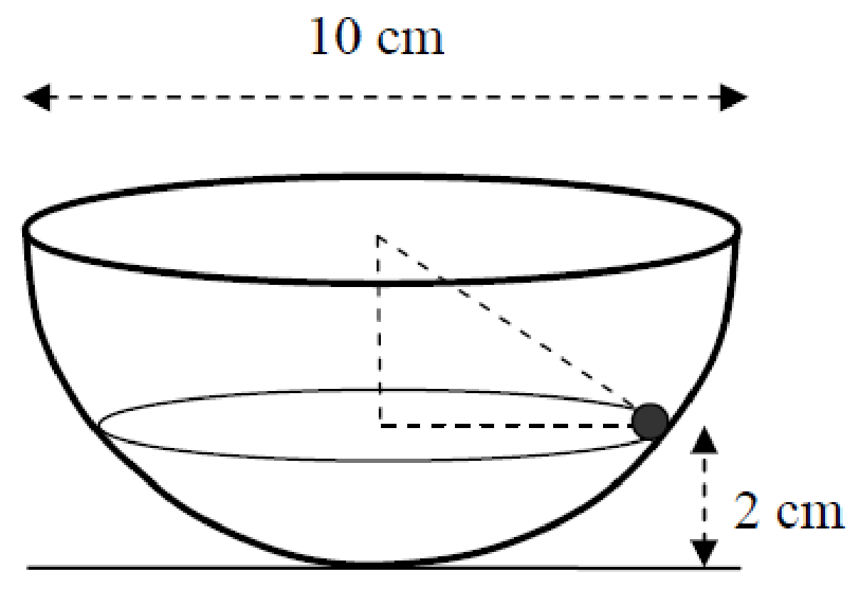
{the marking scheme here is incorrect; they didn’t convert a distance of 4 cm to 0.04 m}
A hemispherical bowl of diameter 10 cm is fixed to a horizontal surface.
A smooth particle of mass 2 kg describes a horizontal circle of radius r cm on the smooth inside surface of the bowl.
The plane of the circular motion is 2 cm above the horizontal surface.
- Find the value of r.
- Show on a diagram all the forces acting on the particle.
- Find the reaction force between the particle and the surface of the bowl.
- Calculate the angular velocity of the particle.

2016 (b) OL
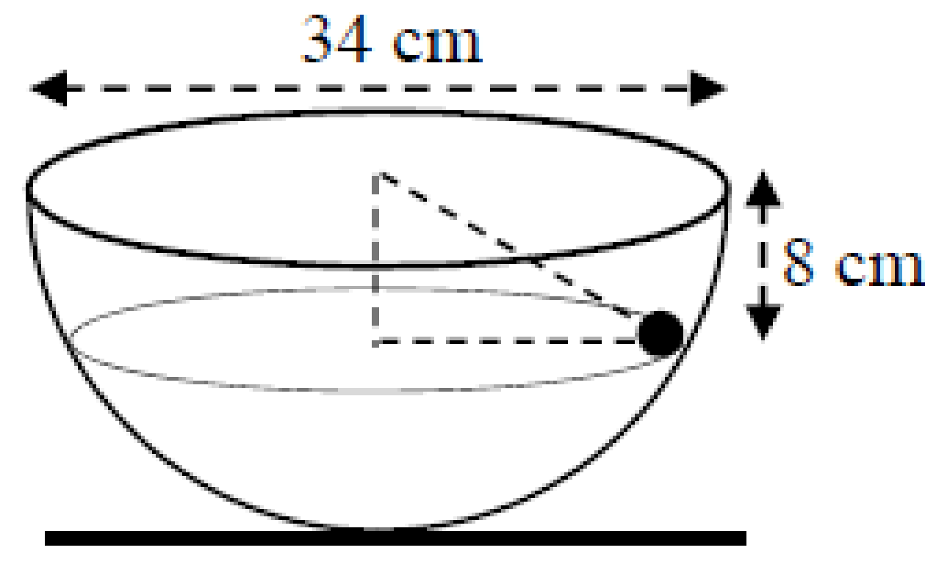
A hemispherical bowl of diameter 34 cm is fixed to a horizontal surface.
A smooth particle of mass 1 kg describes a horizontal circle of radius r cm on the smooth inside surface of the bowl.
The plane of the circular motion is 8 cm below the top of the bowl.
- Find the value of r.
- Find the reaction force between the particle and the surface of the bowl
- Find the angular velocity of the particle.

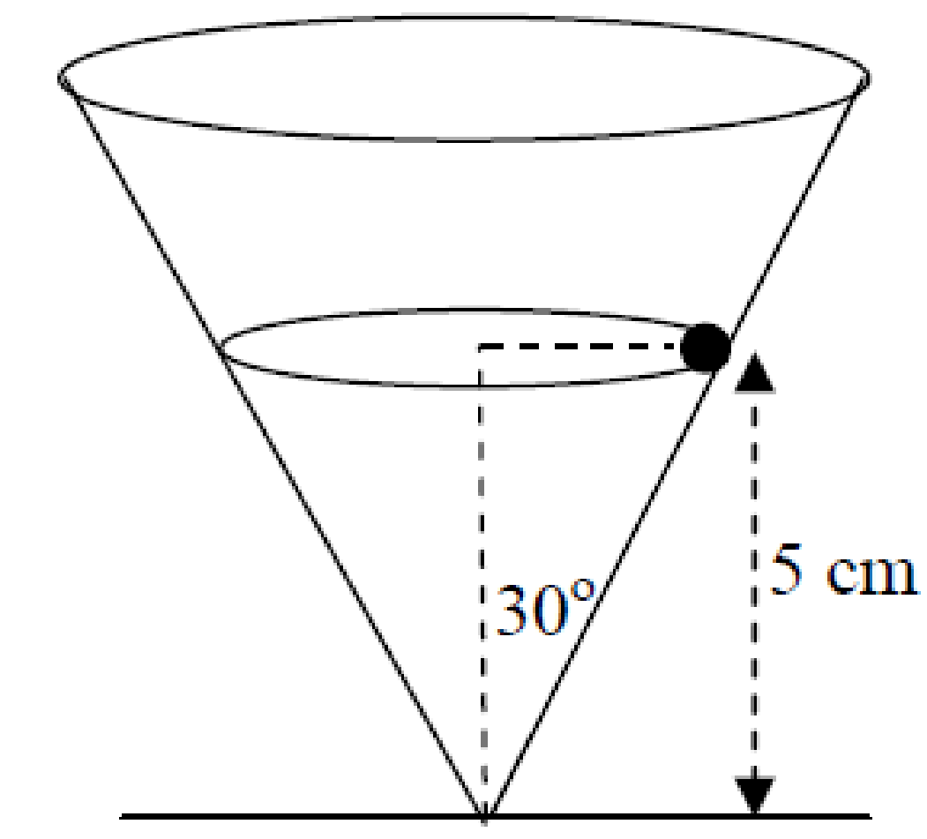
2009 (b) OL
A right circular hollow cone is fixed to a horizontal surface.
Its semi-vertical angle is 30^{ο} and its axis is vertical.
A smooth particle of mass 2 kg describes a horizontal circle of radius r cm on the smooth inside surface of the cone.
The plane of the circular motion is 5 cm above the horizontal surface.
- Find the value of r in surd form.
- Show on a diagram all the forces acting on the particle.
- Find the reaction force between the particle and the surface of the cone.
- Calculate the angular velocity of the particle.

Cones and spheres questions without friction– Higher level

These are the very same as the ordinary level questions above, although if no image is provided it can be a little more difficult to work out the various aspects of the geometry diagram.

1984 (a)
A particle moving on the inside smooth surface of a fixed hollow sphere of internal radius $\sqrt{2}$ m describes a horizontal circle of radius 1 m.
Calculate the angular velocity of the particle.

1979 (a)
A particle moving at constant speed, is describing a horizontal circle on the inside surface of a smooth sphere of radius r.
The centre of the circle is a distance ½ r below the centre of the sphere.
Prove that the speed of the particle is.

Cones and spheres questions with friction– introduction
Before we look at cones/spheres questions with friction, we first look at a couple of straightforward circular motion questions involving friction

2003 (a) OL
A vehicle of mass 1000 kg rounds a bend which is in the shape of an arc of a circle of radius 25 m.
The coefficient of friction between the tyres and the road is 0.8.
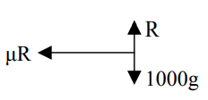
- Show on a diagram the three forces acting on the vehicle.
- Calculate the maximum speed with which the vehicle can round the bend without slipping.
Give your answer correct to two places of decimals.

Diagram 1: Geometry diagram | Diagram 2: Forces diagram
Not necessary as we just have horizontal and vertical forces

Now for our two equations

Force up = Force down | Net force inwards = $\frac{mv^{2}}{r}$
R = 1000g | The only force that’s acting in towards the centre is the friction force: μR  μR = $\frac{mv^{2}}{r}$  (0.8) (1000g) = $\frac{1000v^{2}}{25}$  ⇒ v = 14.14 m s⁻¹

2023 OL Question 2 (a)
A piece of clay of mass 0.335 kg rests on a horizontal potter’s wheel, which is rotating with period 𝑇 = 1.2 s.
The clay moves with uniform circular motion of radius 𝑟.
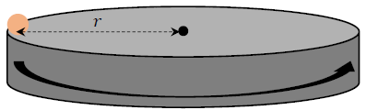
The coefficient of friction between the wheel and the clay is ½.
- Draw a labelled diagram to show the forces acting on the clay.
- Calculate the force of friction that acts on the clay.
- Calculate 𝜔, the angular velocity of the clay.
- Calculate the value of 𝑟.

2000 (a) [Higher Level]
A particle is placed on a horizontal rotating turntable, 10 cm from the centre of rotation.
There is a coefficient of friction of 0.4 between the particle and the turntable.
If the speed of the turntable is gradually increased, at what angular speed will the particle begin to slide?

Cones and spheres questions with friction– Ordinary level
What direction does friction act?
Answer: It will be opposite to the direction of motion, so either tangentially upwards or tangentially downwards. If the particle is about to slide down (tangentially downwards) then the friction force acts in the opposite direction (tangentially upwards) and if the particle is about to move up (tangentially upwards) then the friction force acts in the opposite direction (tangentially downwards).

So how can we tell if the particle is above to move upwards or downwards?
Short answer: Why there just ain’t no way to tell!

Longer answer part (i)
If the particle is moving very fast it will most likely move upwards, and if it’s moving slowly it will most likely move downwards. The same applies to the situation where the ball is just placed in position and the wall itself rotates. You can demonstrate this by placing an object with a smooth surface (like a computer mouse or highlighter) on a smooth surface (like a hardback copy). Now hold the copy at arm’s length, tilt it upwards so that the object is still stationary on the surface. Now turn around. If you rotate quickly the object will slide upwards and ‘fly’ off the surface, but if you rotate slowly the object will slide downwards. Note that this is a demonstration (and a pretty cool demonstration at that) but not an explanation.
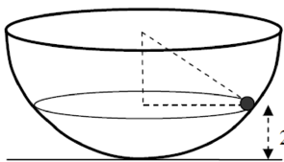
Longer answer part (ii)
Consider a marble of mass 2 kg describing a horizontal circle on the inside surface of a smooth bowl (no friction).

The forces are shown below.
If the marble was going to move upwards then the upward component of R would have to be greater than 2g.
Now the faster the marble moves, the greater will be the force inwards on the wall of the bowl. From Newton’s third law of motion the force that the bowl exerts on the marble (the normal reaction force) will be equal and opposite in direction to this force so by increasing the speed, we increase the reaction force. The upward component $(R\sin{α})$ increases accordingly.
So the faster the particle (or the surface) moves, the greater will be the upward component of the normal reaction force, and if that upward component is greater than the gravitational force the particle will start to accelerate upwards.

But given that we don’t know the normal reaction force at the beginning of the question there is no way to know whether it’s upward component is greater or less than the gravitational force, therefore no way to know if the particle will move up or down, therefore no way to know which way friction will act.

2004 (b) OL {this one could/should be a higher level question}
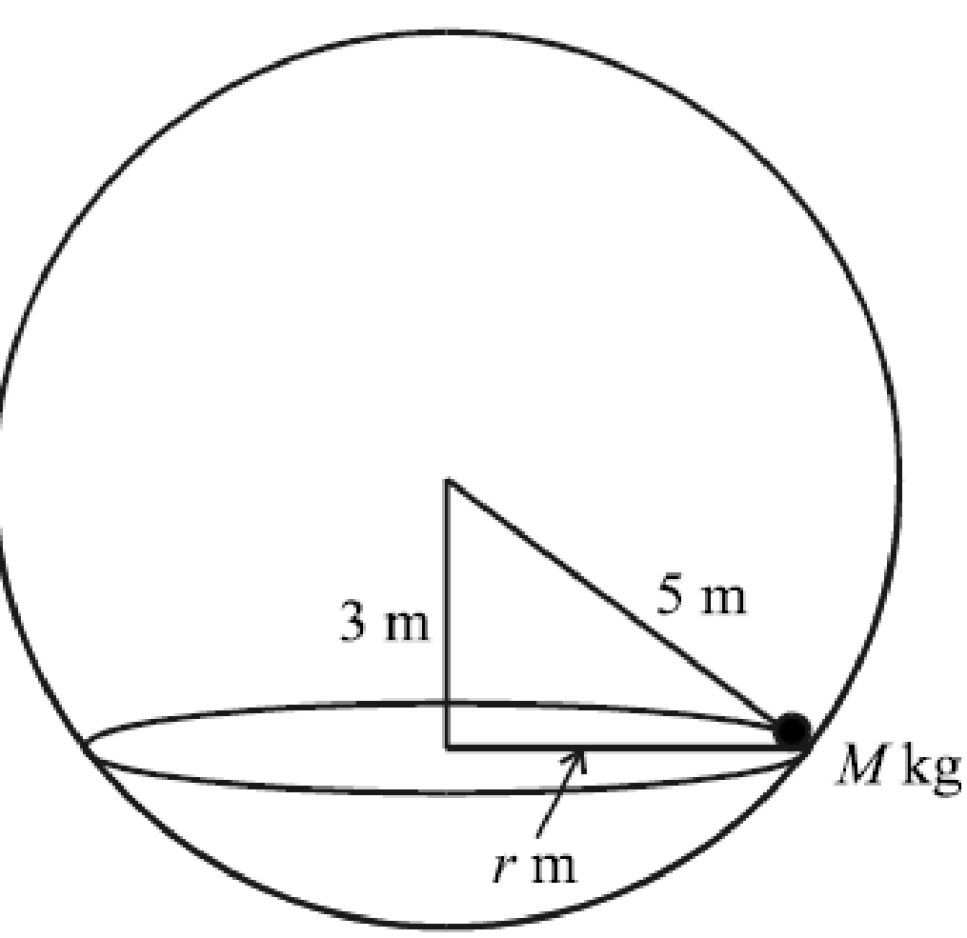
A circus act uses a fixed spherical bowl of inner radius 5 m.
A girl and her motorcycle together have a mass of M kg, as shown in the diagram.
The girl and her motorcycle describe a horizontal circle of radius r m, with angular velocity ω rad/s, on the inside rough surface of the bowl.
The centre of the horizontal circle is 3 m vertically below the centre of the bowl.
The coefficient of friction between the motorcycle tyres and the bowl is 3/4.
- Find the value of r.
- Show on a diagram all the forces acting on the mass M.
- Find the value of ω, correct to two decimal places.

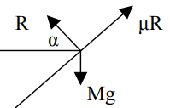
In this case the marking scheme assumed that the ‘object’ will be on the point of moving tangentially downwards so the friction acts in the opposite direction (tangentially upwards). Presumably it would have assigned full marks to anyone who assumed that the object was on the point of moving upwards also.
The second challenge here is to assign the correct angle to the correct position in the geometry diagram. See if you can fill in the angles for the diagram on the right before proceeding any further. Every relevant angle will either be $α$ or $(90-α)$.

Cones and spheres questions with friction– Higher level

1983
A hollow right circular cone of semi-vertical angle α where tan α = ¾ is fixed with its axis vertical and vertex downwards.
The inner surface of the cone is rough with coefficient of friction ½ and the cone rotates about its axis with uniform angular velocity 7 rad/s.
A particle of mass m is placed on the inside surface and rotates with the cone at a vertical height h above the vertex.
Calculate the normal reaction of the particle with the inside surface and the height h above the vertex if
- the particle is about to slide down
- the particle is about to slip up.

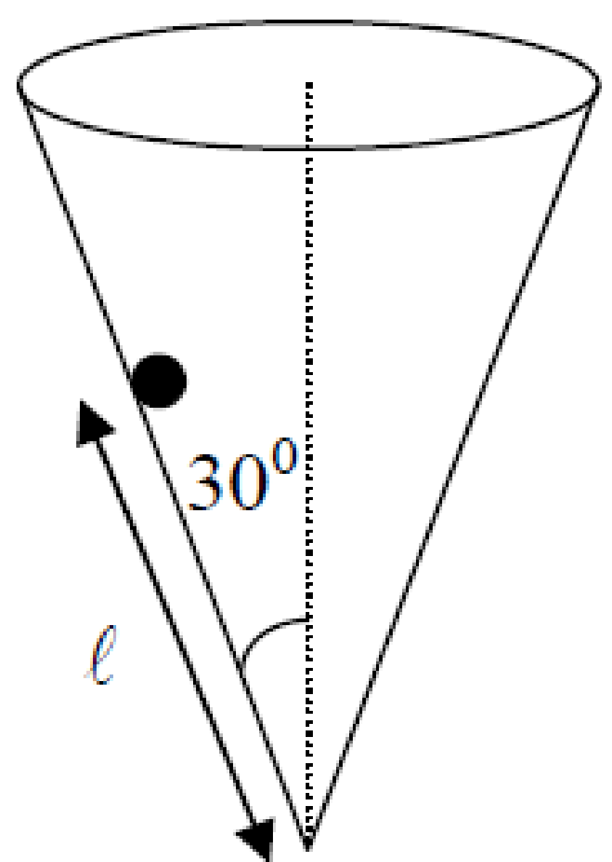
2006 (b)
A hollow cone with its vertex downwards and its axis vertical, revolves about its axis with a constant angular velocity of 4π rad/s.
A particle of mass m is placed on the inside rough surface of the cone.
The particle remains at rest relative to the cone.
The coefficient of friction between the particle and the cone is 1/4.
The semi-vertical angle of the cone is 30° and the particle is a distance l m from the vertex of the cone. Find the maximum value of l, correct to two places of decimals.

Hint:
The fact that the question is looking for a ‘maximum’ value for l suggests that the particle will be moving upwards along the surface so again the friction force will be acting in the opposite direction.
I’m guessing that if the particle was to go beyond this point it would no longer move in a circular path but would instead move up and out of the cone.
But what do I know.

Vertical motion

Particle on a string
Here we need to use conservation of energy to get a second equation

- $Net Force Inwards= \frac{{mv}^{2}}{r}$ equation 1
- KE + P.E. at beginning = K.E. + P.E. at any other point equation 2
- Solve equations (simplest way is to get v² from equation 1 and sub into equation 2)
- If the string goes slack it means that the tension T = 0
The trickiest aspect to these questions is usually getting an expression for the height

Sample paper Ordinary Level Question 1 (b)
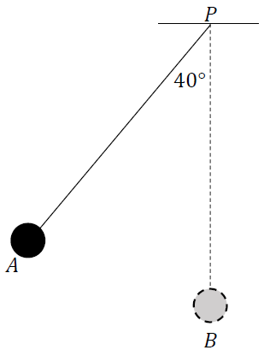
A small smooth sphere of mass 2 kg is connected by a light inextensible string of length 3 m to a fixed point 𝑃.
The sphere is held at position 𝐴, where the taut string makes an angle of 40° to the vertical, as shown in the diagram. The sphere is then released from rest.
The motion of the sphere may be modelled using the principle of conservation of energy.
- Using this model, calculate the speed of the sphere as it passes through position 𝐵, when the string is vertical.
- Calculate the centripetal force on the sphere as it passes through 𝐵.
- Calculate the tension in the string when the sphere passes through 𝐵.

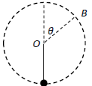
2020 (b)
A particle P is attached to one end of a light inextensible string of length 𝑑.
The other end of the string is attached to a fixed point O.
The particle is hanging freely at rest, with the string vertical, when it is projected horizontally with speed $\sqrt{3gd}$.
The particle moves in a vertical circle.
The string becomes slack when P is at the point B.
OB makes an angle 𝜃 with the upward vertical.
- Show that cos 𝜃 = $\frac{1}{3}$.
- In terms of 𝑑, find the greatest height of P above B in the subsequent motion.

2022 Deferred (b)
A particle of mass m is suspended vertically from a fixed point O by a light inelastic string of length d metres.
The particle is projected horizontally with speed u, where u² = 4gd.
Show the string goes slack when it makes an angle $\cos^{-1}{\frac{2}{3}}$ with the upward vertical through O.

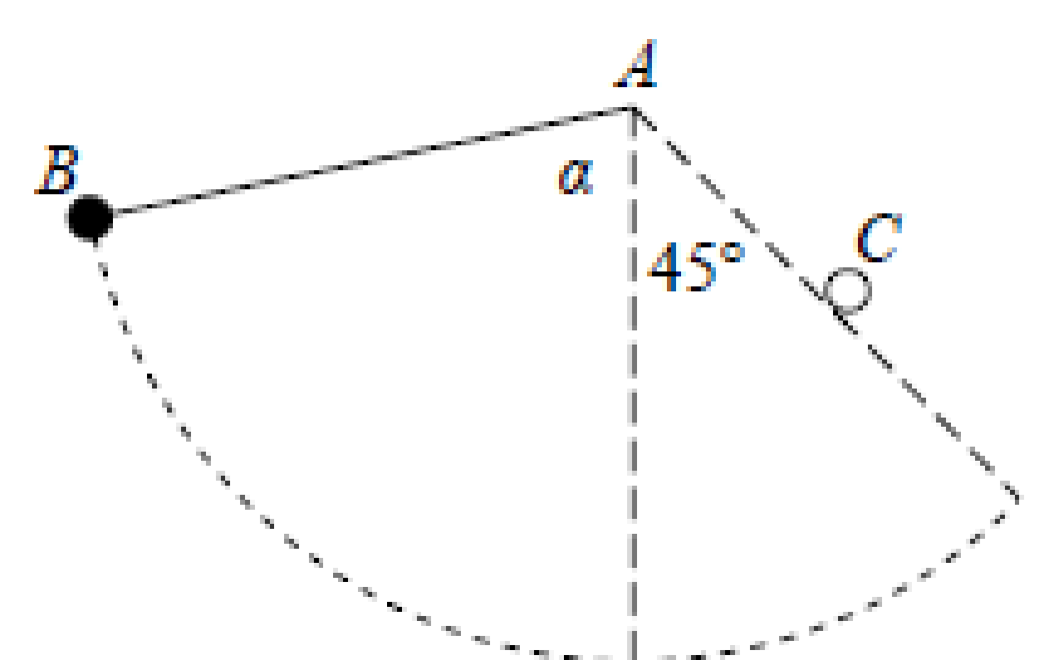
2014 (b)
A particle of mass m, is suspended by a light inextensible string AB of length 2d.
The end A is fixed and the particle is released from rest when AB makes an angle α with the downward vertical through A.
When B has risen again to a height so that AB makes an angle of 45° with the downward vertical, the midpoint of the string comes into contact with a small horizontal peg C.

- If cos α = ¼ find, in terms of d, the speed of the particle at the moment that the string touches the peg.
- Find, in terms of m, the tension in the string when the particle reaches the same height as the peg.

1997
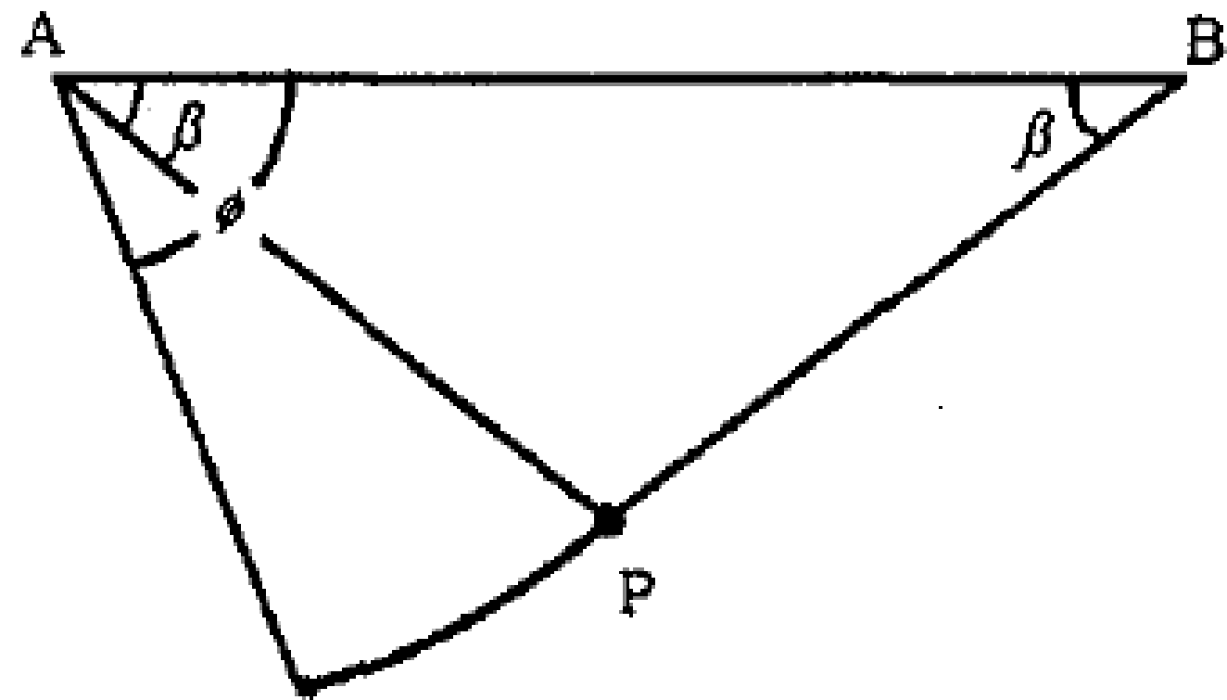
A particle P, of mass m, is suspended by two inextensible light strings PA, PB, of equal length where A and B are fixed at the same horizontal level and each string is inclined at an angle β to the horizontal.
- Find the tension in the string PA.
- If the string PB is cut so that P starts to move in a circular path, prove that the tension in the string PA when it makes an angle φ with the horizontal is mg(3sinφ – 2sinβ ).
- If the tension in PA is suddenly halved when PB is cut, find the angle β.

Maximum and minimum tension in a string
The tension in a string will be a maximum when the particle is at the lowest point of its motion and will be a minimum when the particle is at the highest point of its motion.

At the very top the forces acting on the particle will be (T + mg)
At the very bottom the forces acting on the particle will be (T – mg)
Remember that both the particle’s linear velocity v and its angular velocity ω will change throughout its motion.

1995 (b)
A particle of mass m, attached to a fixed point by a light inelastic string, describes a circle in a vertical plane.
The tension of the string when the particle is at the highest point of the orbit is T₁ and when at the lowest point it is T₂.
Prove that T₂ = T₁ + 6mg

2022 (b)
A particle is attached to one end of a light inextensible string of length 0.5 m.
The other end of the string is attached to a fixed point C. The particle moves in a vertical circle.
The greatest and least tensions in the string are 3T and T, respectively.
Find the speed of the particle at the lowest point.

2017 (b)
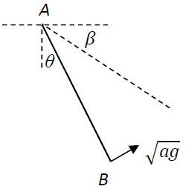
One end A of a light inextensible string of length 3a is attached to a fixed point.
A particle of mass m is attached to the other end B of the string.
The string makes an angle θ with the vertical.
The particle is held in equilibrium with the string taut and cos θ = $\frac{2}{3}$

The particle is then projected with speed$\sqrt{ag}$, in the direction perpendicular to AB, as shown in the diagram.
In the subsequent motion the string remains taut.
When AB makes an angle β below the horizontal, the speed of the particle is v and the tension in the string is T.
- Show that $v^{2}=3ag\left(2sinsin β -1\right)$.

- Find the minimum value and the maximum value of T.

Car doing a loop-the-loop

There are two conditions that would prevent the car in this context moving in a circular path; if it’s speed is zero or if the reaction force acting on the car is zero so we look at the condition which comes in to play first – in this case the reaction force going to zero.
So for the question below we get two equations as normal, and then note that at the reaction force = 0 at the point in question. Note that you must write the complete equation showing all theoretical forces and only afterwards can you eliminate the reaction force. I am not sure why you have to do this, but ours is not to wonder why.

Note also that if the car is doing a full revolution then the reaction force at the very top will be zero. This is becusae (similar to a projectile) the car will be moving horizontally at the very highest point so will no longer be pressing into the surface, so from N III the surface will not be exerting a force on the car (but only at that highest point).

2023 HL Question 10 (b)
A toy car track consists of a series of components that connect to make a closed circuit.
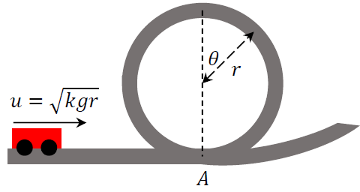
Part of the track makes a vertical circular loop.
To model the motion of a car on this track, its velocity at the base of the loop (point 𝐴) is expressed as $u=\sqrt{kgr}$, where 𝑟 is the radius of the loop, 𝑔 is the acceleration due to gravity, and 𝑘 is a constant.
The model ignores the effects of friction.
- Draw a diagram to show the forces acting on the car at the instant when the radius to the car makes an angle 𝜃 with the upward vertical.

- If the car loses contact with the track at the instant when the radius to the car makes an angle 𝜃 with the upward vertical, show that $\cos{θ=\frac{k-2}{3}}$.

- Calculate the minimum value of 𝑘 such that the car successfully completes the loop without losing contact with the track.

Calculate the least speed of projection needed to ensure that the particle just reaches the top of the circle
The particle must be under tension to undergo circular motion but if it just reaches the highest point then we can assume that tension just goes to zero at that point.
See 2016 (a) part (i) and 2018 (b) part (i) below.

2016 (a)
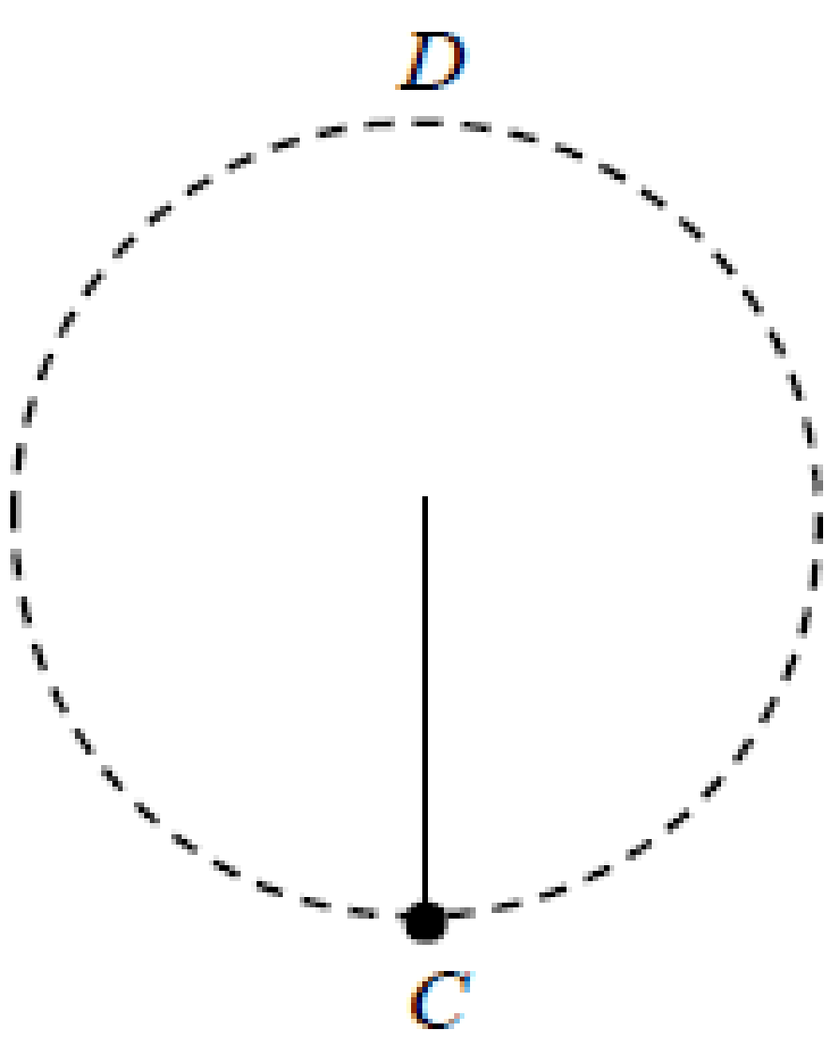
A small particle hanging on the end of a light inextensible string 2 m long is projected horizontally from the point C.
- Calculate the least speed of projection needed to ensure that the particle reaches the point D which is vertically above C.
- If the speed of projection is 7 m s^{–1} find the angle that the string makes with the vertical when it goes slack.

Solution to part (i)
Condition for a particle to reach the top:
The temptation is to say that for the particle to reach the top it must have a speed greater than zero; this is indeed the approach we take when dealing with a projectile but here we also have to consider the fact that the particle is attached to a string and if the string becomes slack at any stage (while the particle is still in motion) it will no longer move in a circular fashion (it would simply become a projectile). It is this second point that comes into play first, so this is the one we need to consider.
So if it just reaches the top we can assume T = 0 at that point.

Conservation of energy  Total energy at C = Total energy at D | Net force inwards at D = $\frac{mv^{2}}{r}$
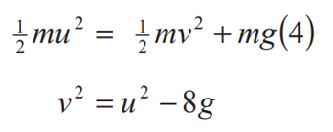 | 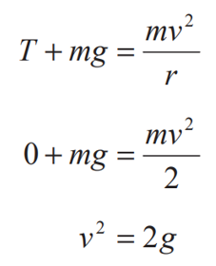
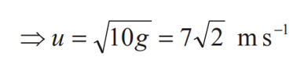
Note that if you mistakenly used v = 0 instead of T = 0 you would get a smaller value for u and the tension would become zero before it reached the top; there would no longer be sufficient tension to produce circular motion (the particle would be become a projectile).

In fact this is exactly what is going on in part (ii) of the question. Here we are now told that the initial speed is 7 m s^{–1} instead of 7√2 and you are asked to find the angle that the string makes with the vertical when it goes slack. In this case it turns out that the string goes slack (T = 0) at an angle of 80.4⁰ even though the particle will still be in motion at that stage.

2018 (b)
A particle P is attached to one end of a light inextensible string of length d. The other end of the string is attached to a fixed point. The particle is hanging freely at rest, with the string vertical, when it is projected horizontally with speed u.
The particle moves in a complete vertical circle.
- Show that u ≥$\sqrt{5gd}$.

- As P moves in the circle the least tension in the string is T₁ and the greatest tension is kT₁.
Given that u =$\sqrt{6gd}$, find the value of k.

Particle slides off the outside surface of a sphere

For most of these questions we are asked to find the speed of the particle when it leaves the surface. We approach this as follows:
- Focus on the point where the particle leaves the sphere and show all forces acting on the particle at that point.

- $Net Force Inwards= \frac{{mv}^{2}}{r}$ equation 1
Reaction force ‘N’ = 0 at release point
- KE + P.E. at release point = K.E. + P.E. at ‘departure’ point equation 2

- Solve equations (simplest way is to get v² from equation 1 and sub into equation 2)

2012 (b)
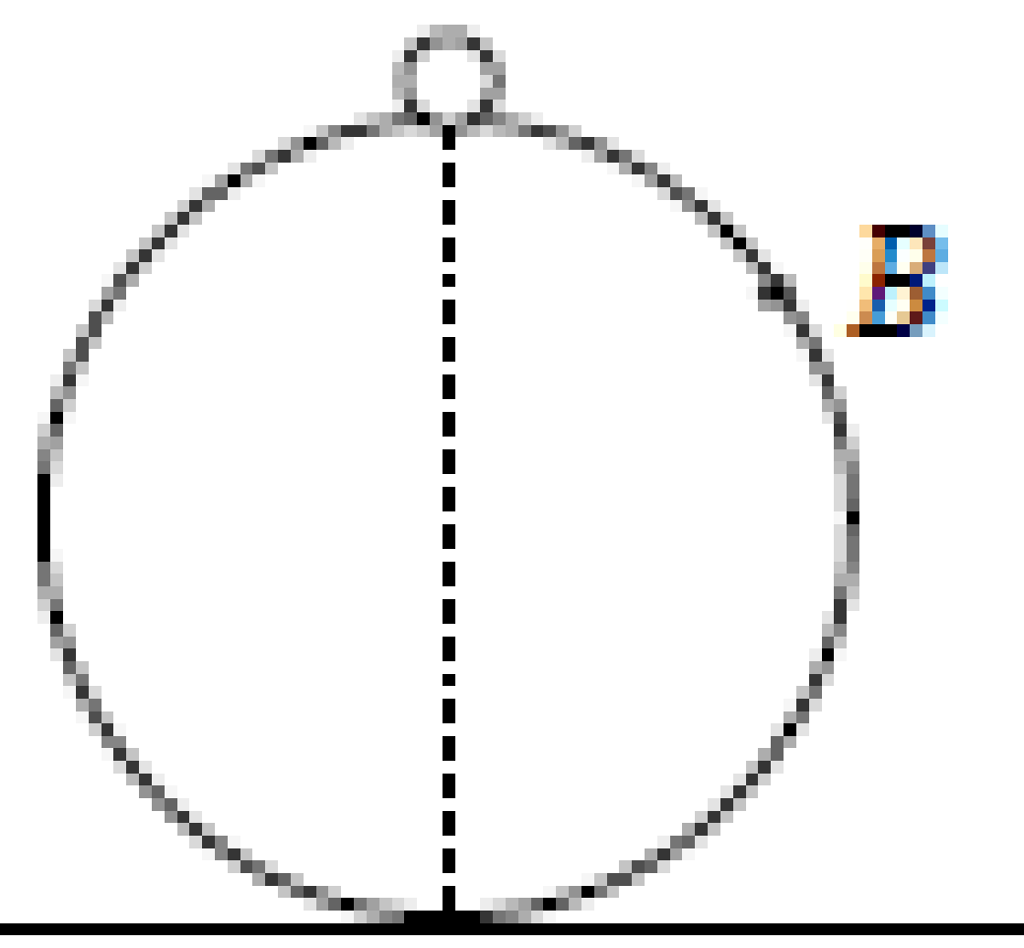
A particle of mass m kg lies on the top of a smooth fixed sphere of radius 30 cm.
The particle is slightly displaced and slides down the sphere. The particle leaves the sphere at B.
- Find the speed of the particle at B.
- The horizontal distance, in metres, of the particle from the centre of the sphere t seconds after it has left the surface of the sphere is $\frac{\sqrt{5}}{10}+ kt$
Find the value of k correct to two places of decimals.

2010 (a)
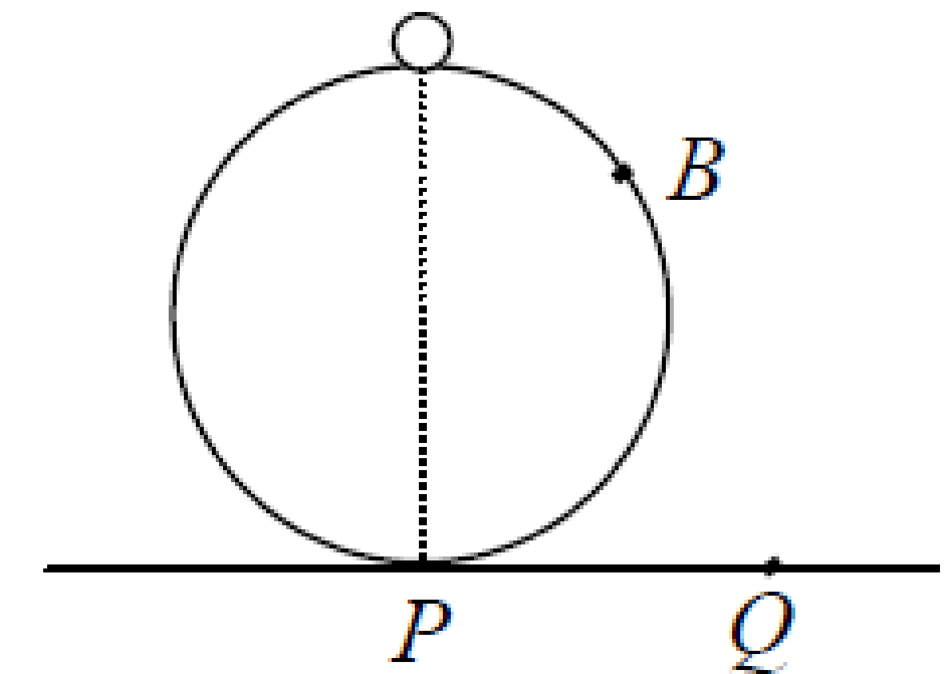
A particle of mass m kg lies on the top of a smooth sphere of radius 2 m.
The sphere is fixed on a horizontal table at P.
The particle is slightly displaced and slides down the sphere.
The particle leaves the sphere at B and strikes the table at Q.
Find
- the speed of the particle at B
- the speed of the particle on striking the table at Q.

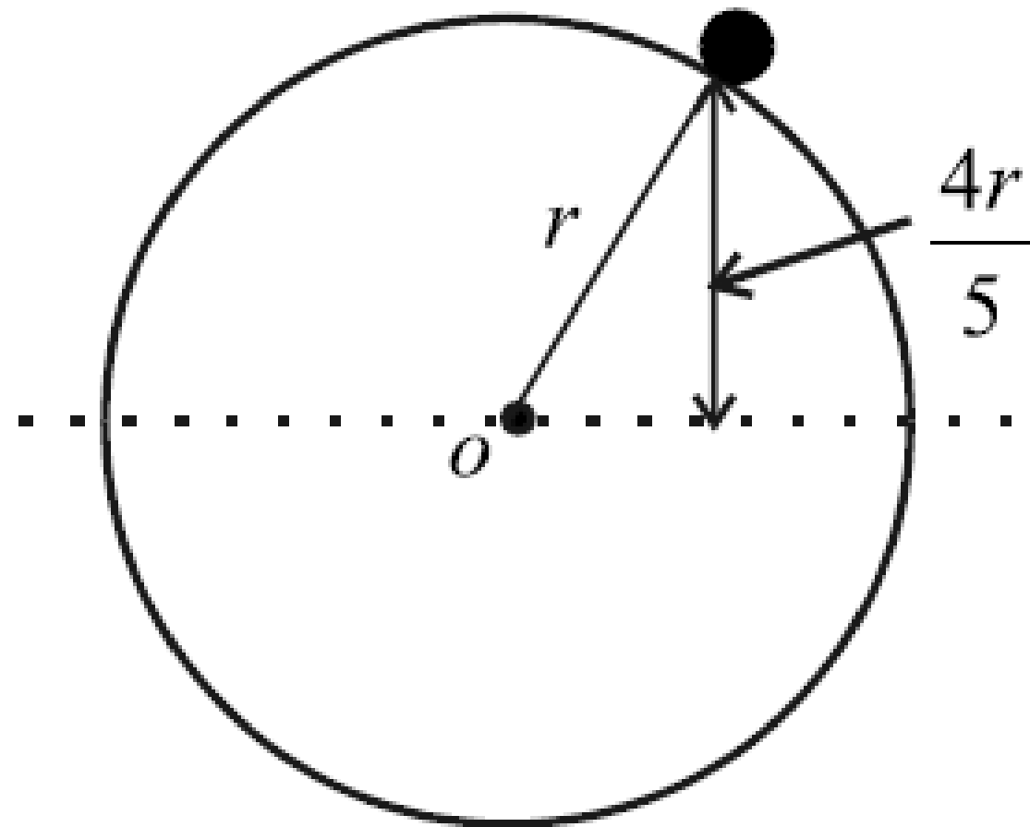
2004 (a)
A particle can move on the smooth outer surface of a fixed sphere of radius r.
The particle is released from rest on the smooth surface of the sphere at a height 4r/5 above the horizontal plane through the centre o of the sphere.
Find, in terms of r, the height above this plane at which the particle leaves the sphere.

2015 (b)
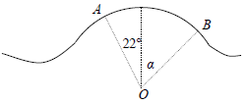
A skier of mass m kg is skiing on a hillside when he reaches a small hump in the form of an arc AB of a circle centre O and radius 7 m, as shown in the diagram.
O, A and B lie in a vertical plane and OA and OB make angles of 22º and α with the vertical respectively.
The skier’s speed at A is 8 m s^{–1}.
The skier loses contact with the ground at point B.
Find the value of α.
2021 (b)
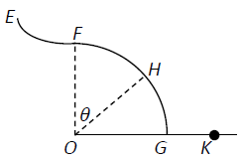
A smooth slide EFG is in the shape of two arcs, EF and FG, each of radius r.
The centre O of arc FG is vertically below F as shown in the diagram.
Point E is at a height $\frac{r}{5}$ above point F.
A child starts from rest at E, moves along the slide past the point F and loses contact with the slide at point H.
OH makes an angle 𝜃 with the vertical.

- Find the value of 𝜃.

- The child lands in a sandpit at point K.
Find, in terms of r, the speed of the child at K.

2003 (b)
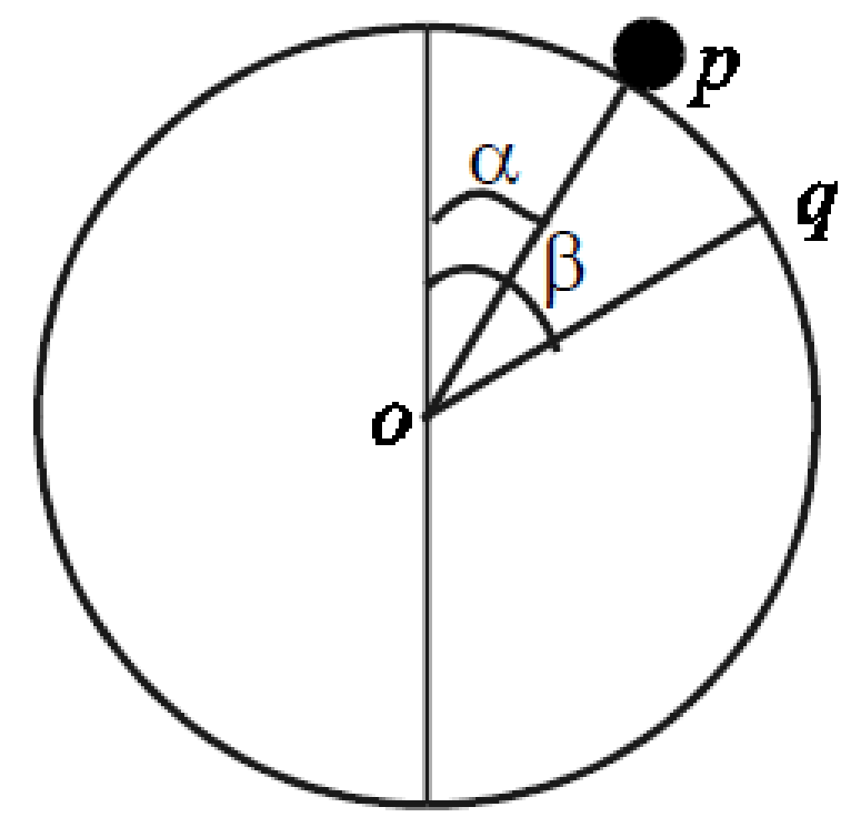
A particle of mass m is held at a point p on the surface of a fixed smooth sphere, centre o and radius r. op makes an angle α with the upward vertical.
The particle is released from rest.
When the particle reaches an arbitrary point q, its speed is v.
oq makes an angle β with the upward vertical.
- Show that v² = 2gr (cosα − cos β).
- If cos α = $\frac{2}{3}$ and if q is the point at which the particle leaves the surface, find the value of β.

Bead on a hoop

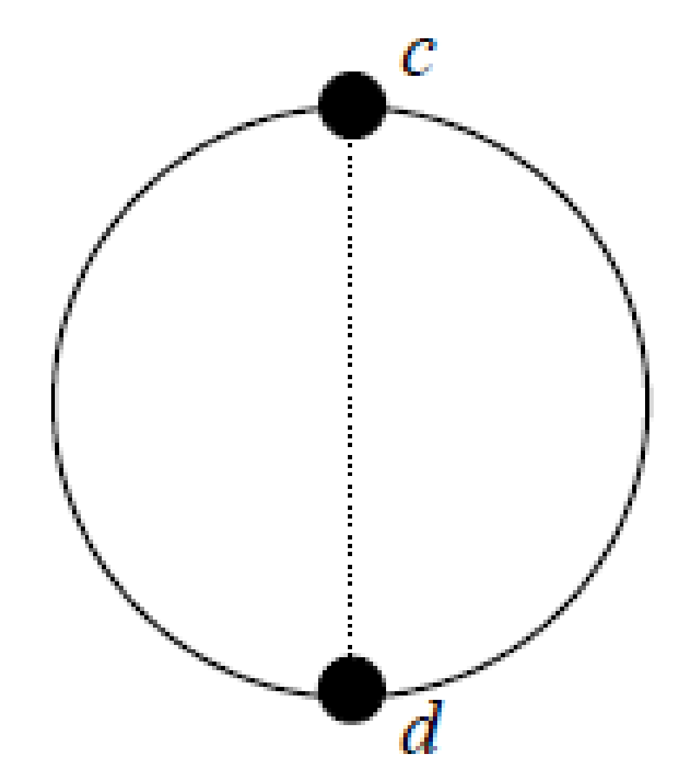
2007 (b)
A bead slides on a smooth fixed circular hoop, of radius r, in a vertical plane.
The bead is projected with speed √(10gr) from the highest point c.
It impinges upon and coalesces with another bead of equal mass at d.
cd is the vertical diameter of the hoop.
Show that the combined mass will not reach the point c in the subsequent motion.

Revision question: Sample Paper HL Question 6
A learner driver is practising driving around a roundabout.

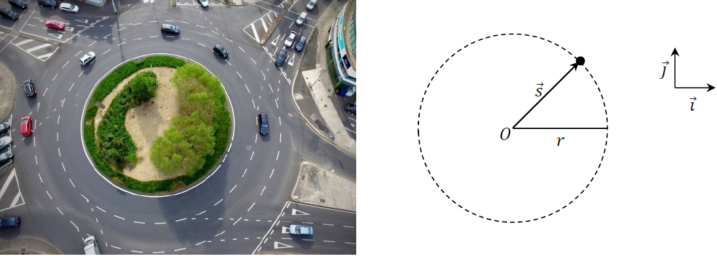

The motion of the car may be modelled as horizontal circular motion around centre 𝑂, with radius 𝑟 and constant angular speed 𝜔, as in the diagram above.
- Write an expression for 𝑠⃗, the displacement of the car relative to 𝑂 at any time 𝑡, in terms of 𝑟, 𝜔 and 𝑡. Your expression should use the unit vectors 𝚤⃗ and 𝚥⃗.
Note that t = 0 when 𝑠⃗ is along the 𝚤⃗ axis.

- Derive an expression for 𝑣⃗, the velocity of the car at any time 𝑡.

- Use a dot product calculation to show that the car’s velocity and displacement are always perpendicular to each other.

- Show that the acceleration of the car is always directed towards 𝑂.

- Derive an expression for the maximum velocity the car could have as it travels around the roundabout, without slipping. Your expression should be written in terms of 𝑟, 𝑔 and 𝜇, the coefficient of friction between the car and the road.

- Use dimensional analysis to show that the units for the expression you derived in part (v) are equivalent to the units for velocity.

- Do you think the assumptions made in developing this model were appropriate?
Explain your answer.

Answers to ordinary level exam questions
2017 (a)
- v = 1.5 m s⁻¹
- a = 4.5 m s⁻²
- F = 9 N
- T = 6π s

2017 (b)
- r = 40 cm

- R = 29 N
- v = 2.05 m s⁻¹

2016 (a)
- ⎤ = 2 rad s⁻¹
- T = π secs
- F= 12 N

2016 (b)
- r = 15 cm
- R = 21.25 N
- ⎤ = 11.18 rad s⁻¹

2015 (a)
- ⎤ = π /3 rad s⁻¹
- v = 2.1 m s⁻¹
- a = 2.2 m s⁻²

2015 (b)
- T = 14.4. N
- R = 11.36 N

2014 (a)
- ⎤ = 5 rad s⁻¹
- v = 10 m s⁻¹
- a = 50 m s⁻²
2014 (b)
- r = 0.5 m
- T = 23.09 N
- ⎤ = 3.4 rad s⁻¹

2013 (a)
- a = 12 m s⁻²
- T = π s

2013 (b)
- r = 4 cm
- diagram
- R = 23.8 N
- v = 0.63 m s⁻¹

2012 (a)
- ⎤ = 3 rad s⁻¹
- F = 72 N

2012 (b)
- r = 8 cm
- R = 16.7 N
- ⎤ = 12.9 rad s⁻¹

2011 (a)
- a = 32 m s⁻²
- T = π/2 s

2011 (b)
- T = 30 N
- R = 12 N

2010 (a)
- r = 3 m
- ⎤ = 2 rad s⁻¹

2010 (b)
- r = 0.8 m
- T = 50 N
- ⎤ = 4.08 rad s⁻¹

2009 (a)
- ⎤ = 8 rad/s
- Period = π/2 s

2009 (b)
- r = 5/√3 cm

- R = 40 N
- ⎤ = √600 rads/s

2008 (a)
- ⎤ = 2.5 rad/s
- Force = 37.5 N

2008 (b)
- r = .04

- R = 100/3
- = √333 rad/s

2007 (a)
- ⎤ = 2 rad/s
- R = 1 m

2007 (b)
- R = 8 N
- ⎤ = 3 rad/s

2006 (a)

- v = 2.5 m s⁻¹, a = 3.2 rad s⁻¹

2006 (b)
- r = 1 m
- T = 80/√3 N
- v = 2.4 m s⁻¹

2005 (a)

- T = 72 N

2005 (b)
- r = 30 cm
- T = 32 N
- N = 14.4. N

2004 (a)
v = 2 m s⁻¹

2004 (b)
- r = 4 m

- = 0.85 rad/sec

2003 (a)

- v = 14.14 m s⁻¹

2003 (b)
- = 30⁰
- T = 18 N

2002
- sin⟨ = 1/√5, cos⟨ = 2/√5

- T = (50√5)/7 N
R = 250/7 N
- ⎤ = 10/7 rad/s

2001
- r = 0.3 m
- cos ⟨ = 0.6, sin ⟨ = 0.8

- R = 25 N
- ⎤ = 5 rad/s

2000
N = T = 104 N

Guide to answering higher level exam questions
2014 (b)
For part (i), the ball is released from the left hand side of the diagram and you are asked to find velocity when ball is at the right hand side of the diagram.
So ball loses PE and gains KE
the marking schemes approach is as follows:
Gain in KE = PE at beginning minus PE at end

Now the string is in contact with the peg and we need to find the velocity (which it calls v1) when the particle rises to the same height as the peg.
Approach is as follows:
KE of particle at the bottom = PE + KE of particle when it is at height of peg.
This gives us a value for v1
Now to find Fnet = mv2/r to find tension.
NOrmally the forces are Tension in and the component of weight acting inwards, but in this situation the string will be horizontal so there is no component of weight.

2008 (b)
Straightforward. Ans: ⎤ = √(3g/2)

2007 (b)
Straightforward. Use conservation of energy to calculate the velocity of the top bead when it reaches the bottom, then use conservation of momentum to calculate the velocity of the combined mass just after the impact and then use conservation of energy again to see how high up the combined mass will go.
Ans: The combined mass will not reach the top again.

2006 (b)
This one was a little unusual, but if you approached it in the usual way you should pick up all the marks.
Get one equation for the forces vertically up equals forces vertically down. The tricky bit is to do with the fact that you would imagine that the ball would tend to fall down, therefore friction should act up along the surface, but in fact because the surface is at an angle, the ball would actually rise up along the surface and therefore friction acts downwards.
I made that sound like I understood it, didn’t I? Don’t be fooled :)
Anyway, get a second equation for net force inwards equals mr⎤² as normal and solve.
Ans: r = 0.43 m.

2005 (a)
Straightforward.
Forces up equal forces down, force in = mr⎤², and use geometry to get an expression for Tan ⎝. Solve.
When you have ⎤ you still need to use the relationship T = 2π/⎤ to get T.
Ans: T= 2π (h/g)

2004 (a)
Straightforward. use conservation of energy to get one equation and net force inwards = mr⎤² to get the second equation. Remember R = 0 at the point where the particle leaves the sphere.
You will also need to use the line going through the centre point as your base-line because the height is given with reference to there.
Then solve.
Ans: h = 8r/15

2003 (b)
- Straightforward in principle. Use conservation of energy: Total energy at q = Total energy at p, using a line through the centre of the circle as the base-line.
- Straightforward in principle. Net force acting inwards = mv²/r. R = 0 at point of departure.
Ans: β = 63.6⁰

2002
- Straightforward. Begin as usual with conservation of energy to get one equation, and net force acting inwards = mv²/r to get the second equation.
- This part was difficult to picture. At this stage the rings will have fallen below the halfway line, and the force exerted by the hoop on the ring will still be the same as before. Now do forces up = forces down. Forces up are N Cos⎝ for each ring and R, but R = 0 at point of departure. This leads to an ugly quadratic where and to solve you need to use the –b +- (√b² – 4ac)/2a formula, where the bit inside the square root must be real.
Ans: m > 3M/2.

2000 (a)
Tricky if you haven’t seen it before, but straightforward if you have (and it does come up every so often). Get an expression for the friction force (F = μR) and a separate expression for circular motion ( F = mr⎤²). Then simply equate to get ⎤ > √(4g).

1997
Full question
- Forces up = forces down and forces left = forces right.
Answer: T = mg/2 sin ®
- Circular motion; use conservation of energy.KE + PE at top = KE + PE at bottom. The trick here is to take the base line as the horizontal line going through A. This means h1 = -l sin ® and h2 = -l sin ⎞.
The second equation in circular motion is F_{c} = mv²/r. As usual with this equation, the tricky part is calculating F_{c} – in this case it is T – mg sin ⎞, but it may require a little playing around with angles to verify that.
- Quite tricky.
First up, you must notice that when the string is cut ⎞ = ®, so the equation in part (ii) reduces to T = mg sin ®.
From part (i) T = mg/2 sin ®, so if this tension is halved it becomes T = ( ½ ) mg/2 sin ®. Now equate this with the general equation T = mg sin ® and solve.
Answer: ® = 60⁰.
Told you it was tricky.

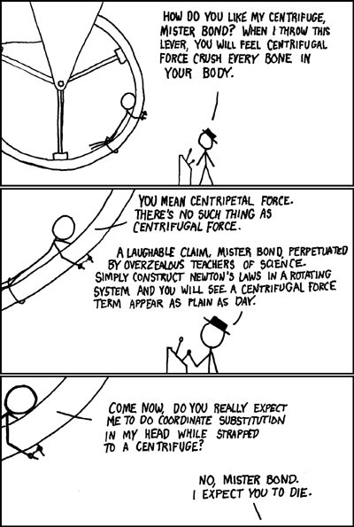

From xkcd

A reminder of what your first page should look like

Diagram 1: Geometry diagram | Diagram 2: Forces diagram

Now for our two equations

Force up = Force down  OR  Conservation of energy | Net force inwards = $\frac{mv^{2}}{r}$  OR  Net force inwards = mrω²

